Goto https://www.oracle.com/java/

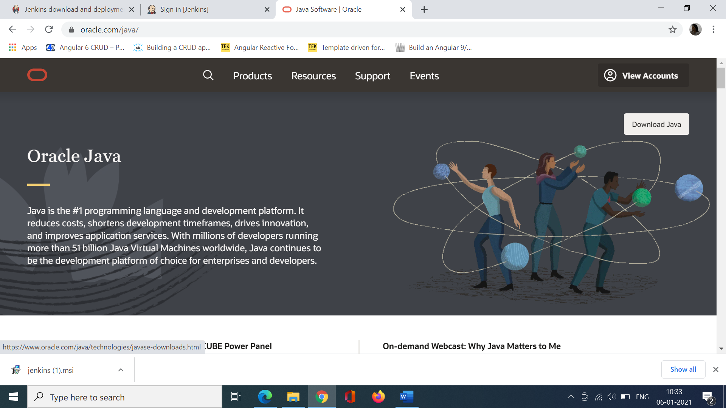

Jenkins supports JDK 11 only. So download jdk 11 .

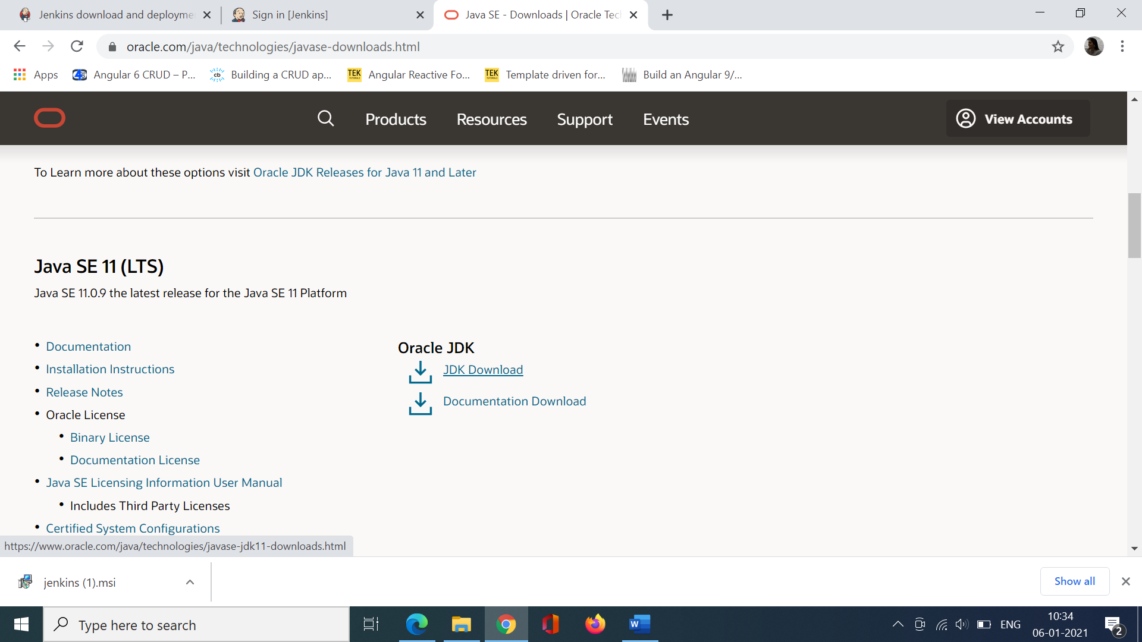

Choose Windows 64.

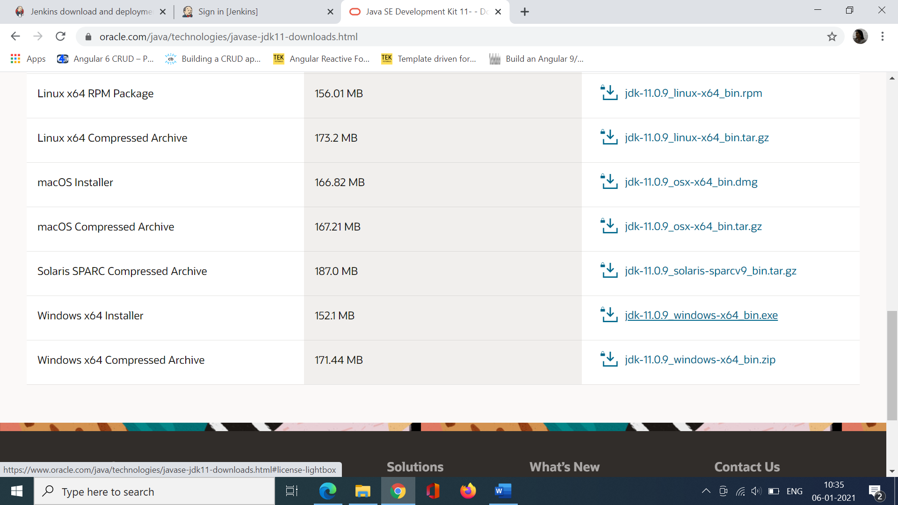

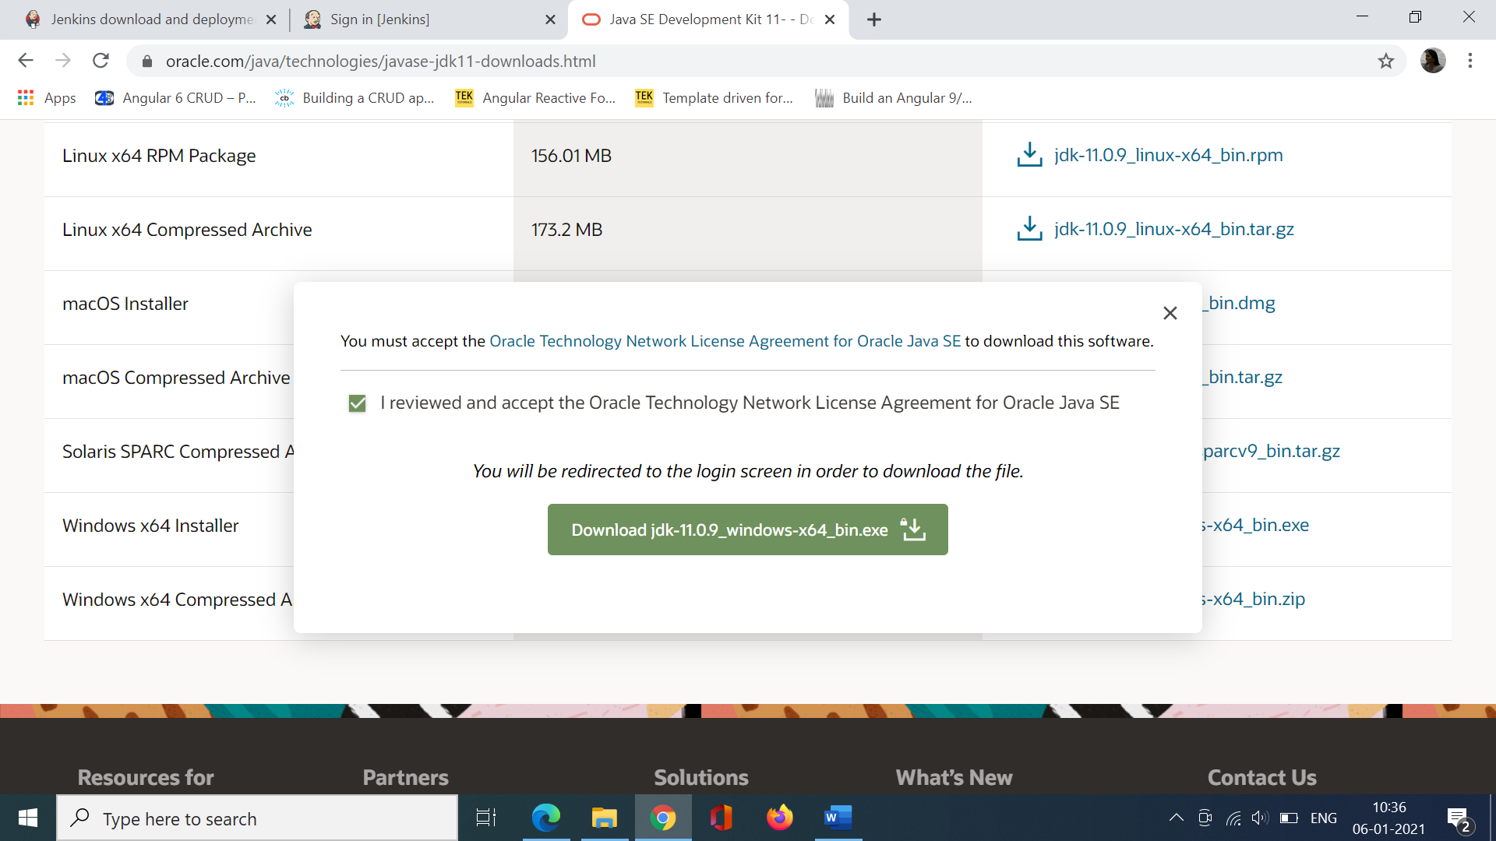

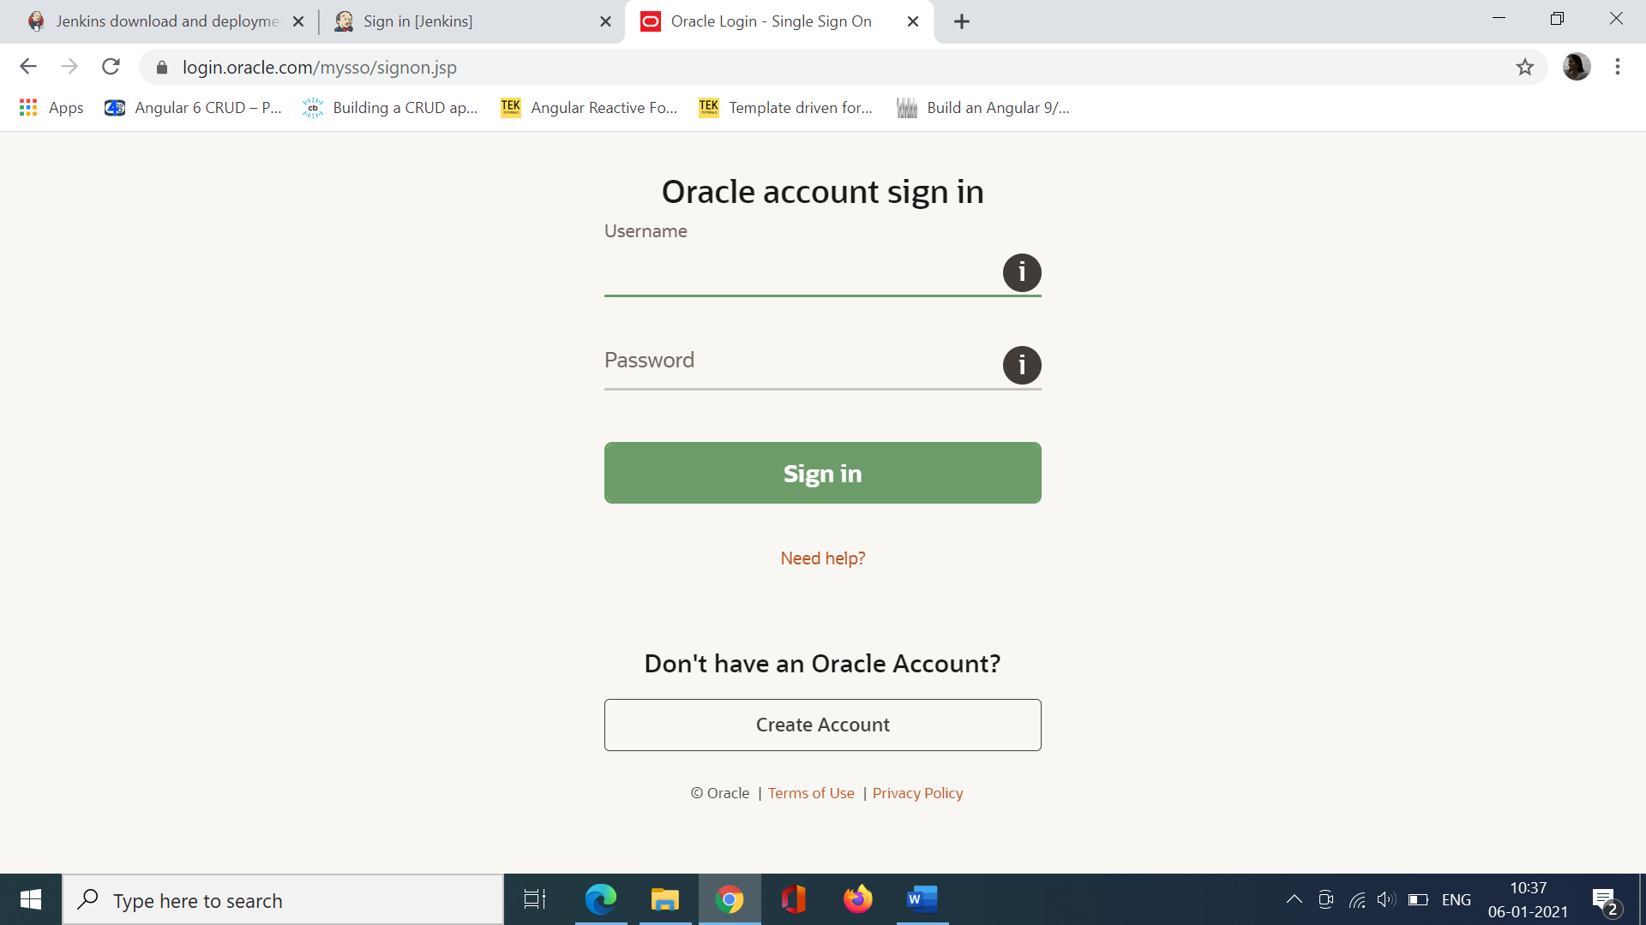

Once I Login the java sdk will be downloaded. Install the JDK file.

Once it is installed successfully goto

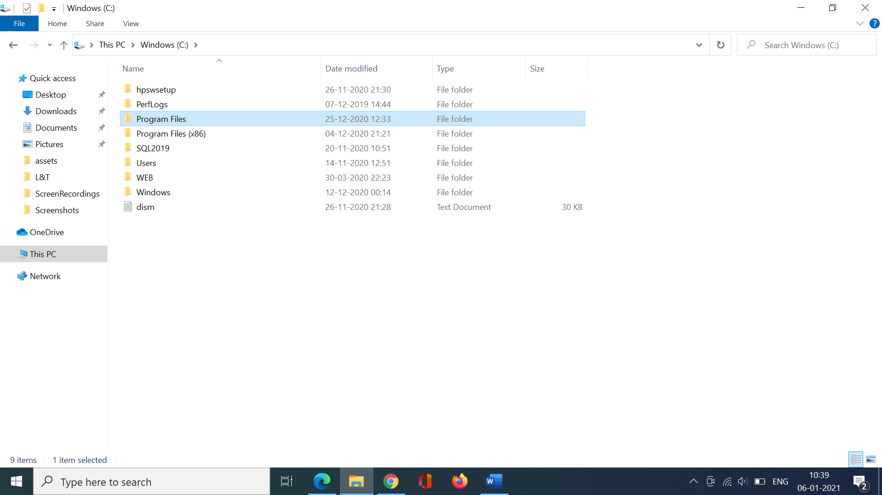

Goto the java folder and you should be able to see the JDK file.

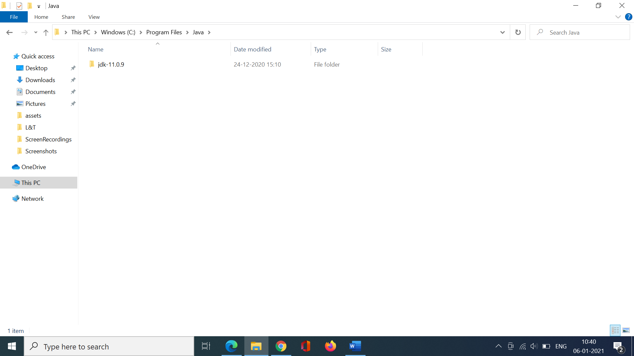

Goto the bin folder and copy the path.

C:\Program Files\Java\jdk-11.0.9\bin

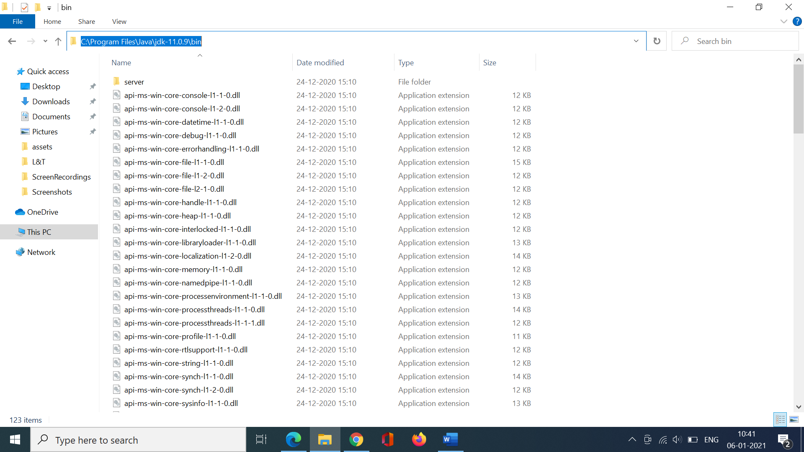

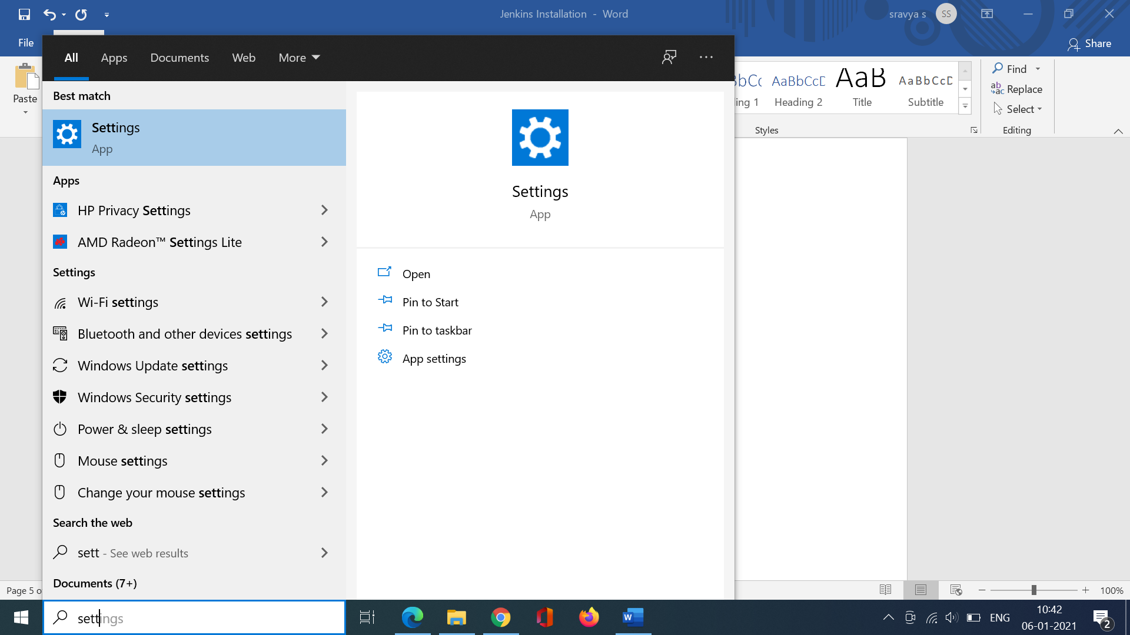

Search for Environment variables

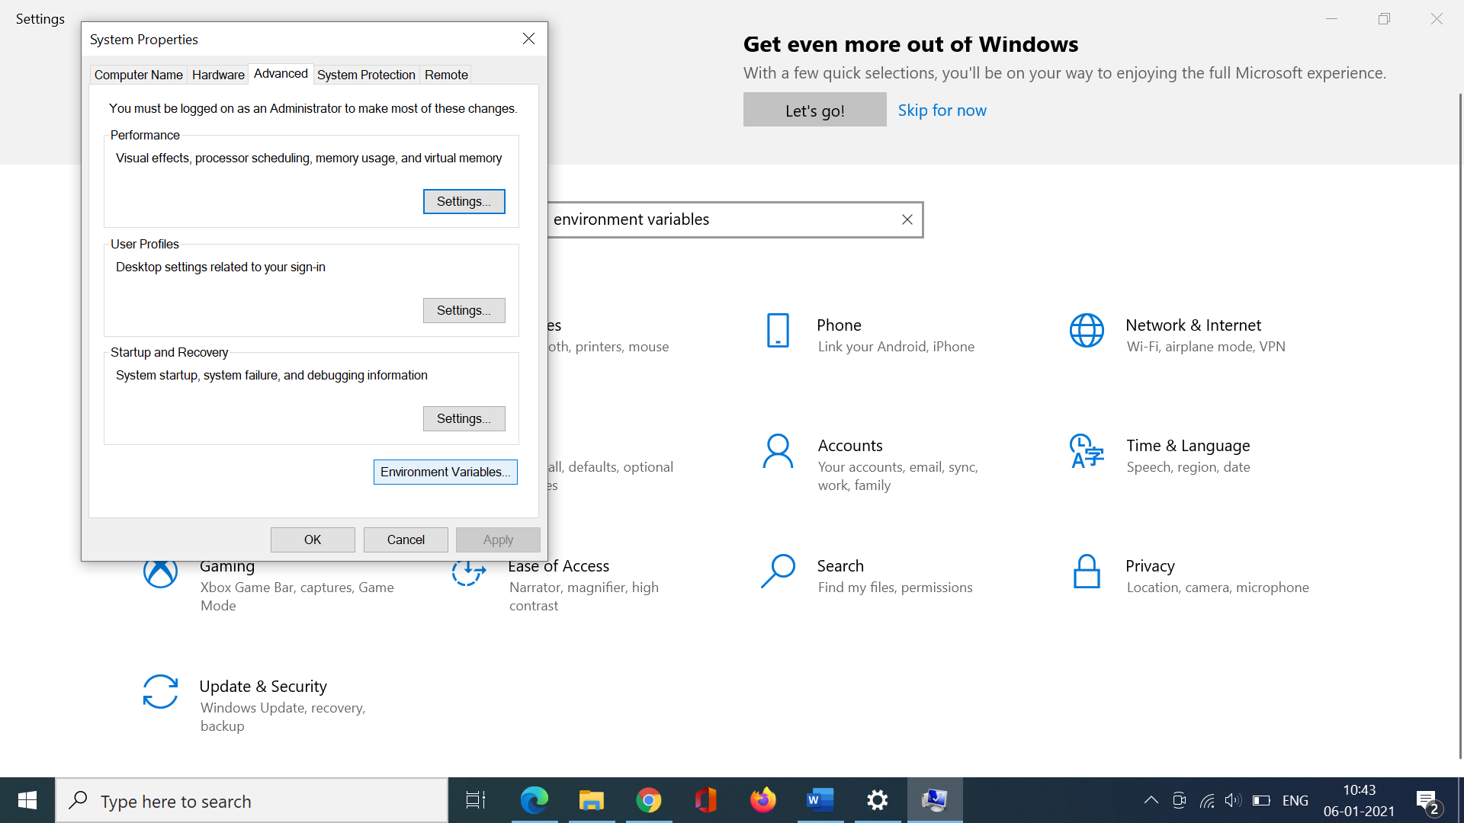

Goto Path. Click Edit. And paste the JDK path if it is not available.

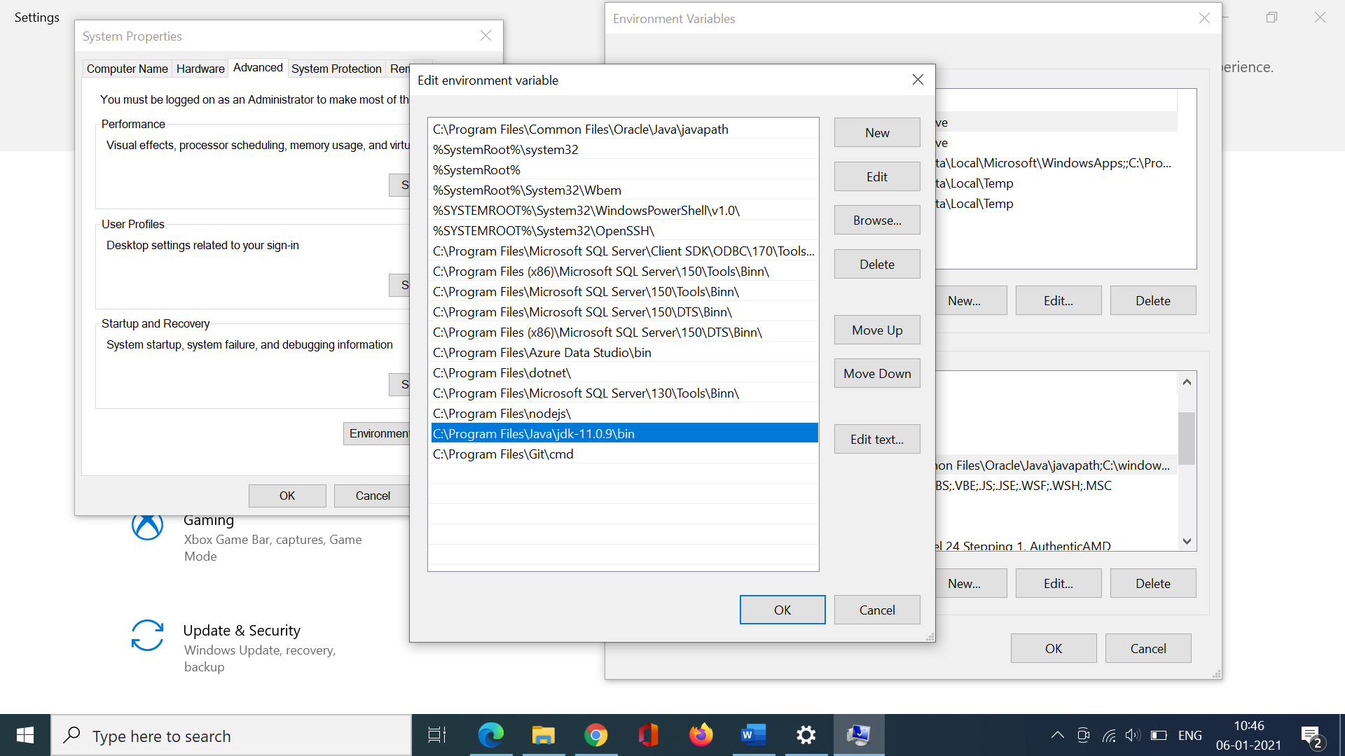

Goto <https://www.jenkins.io/> and click on download.

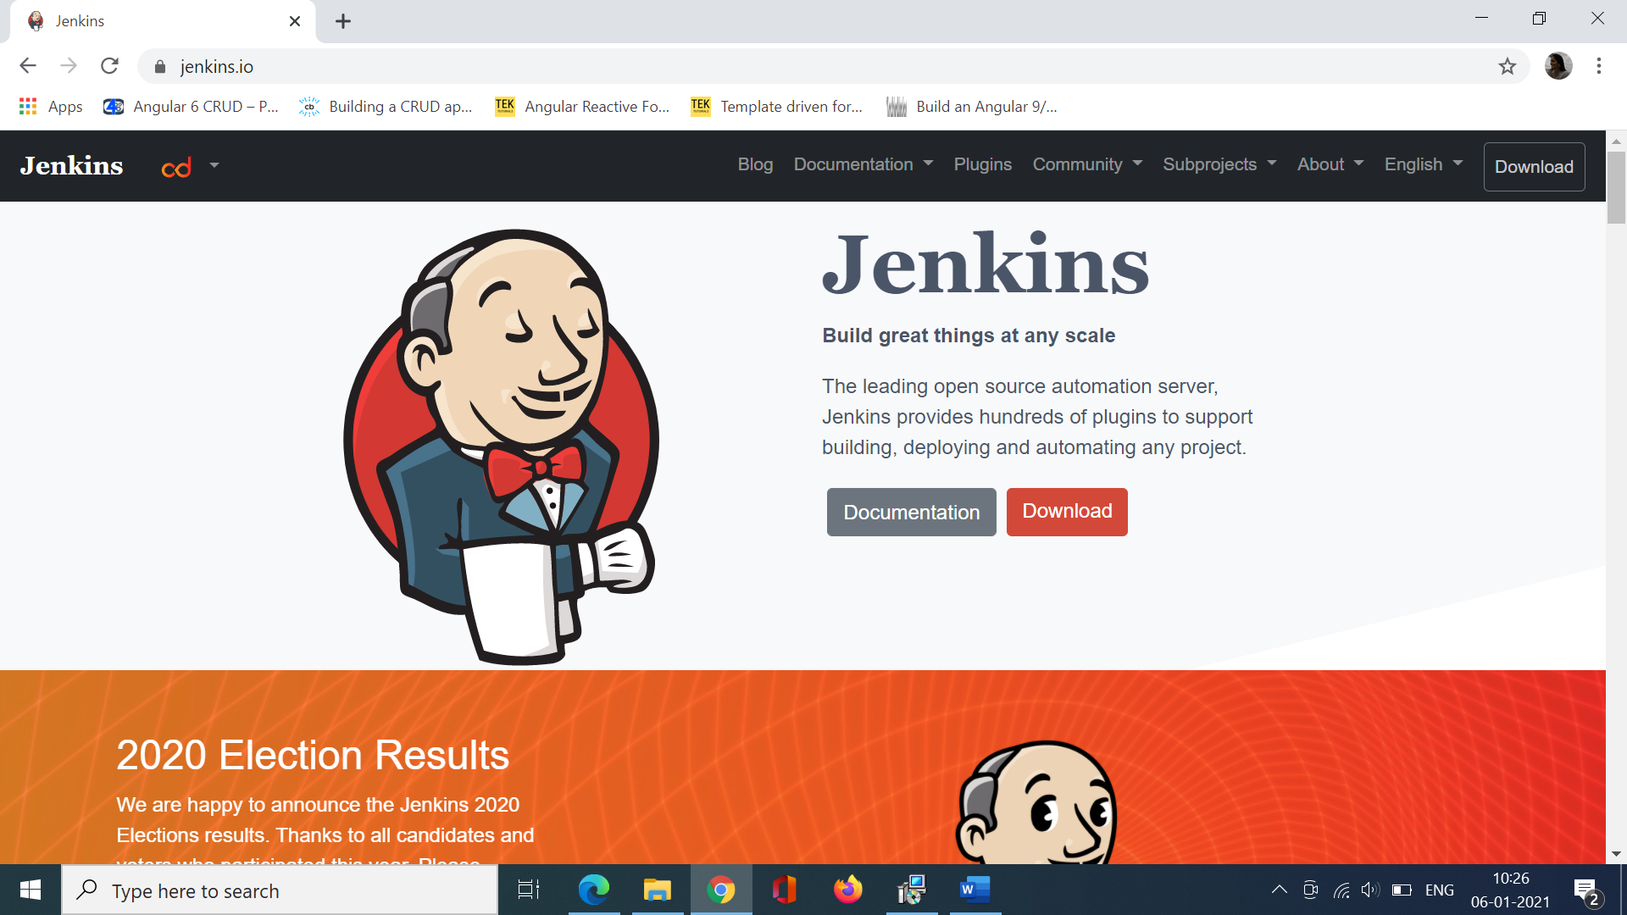

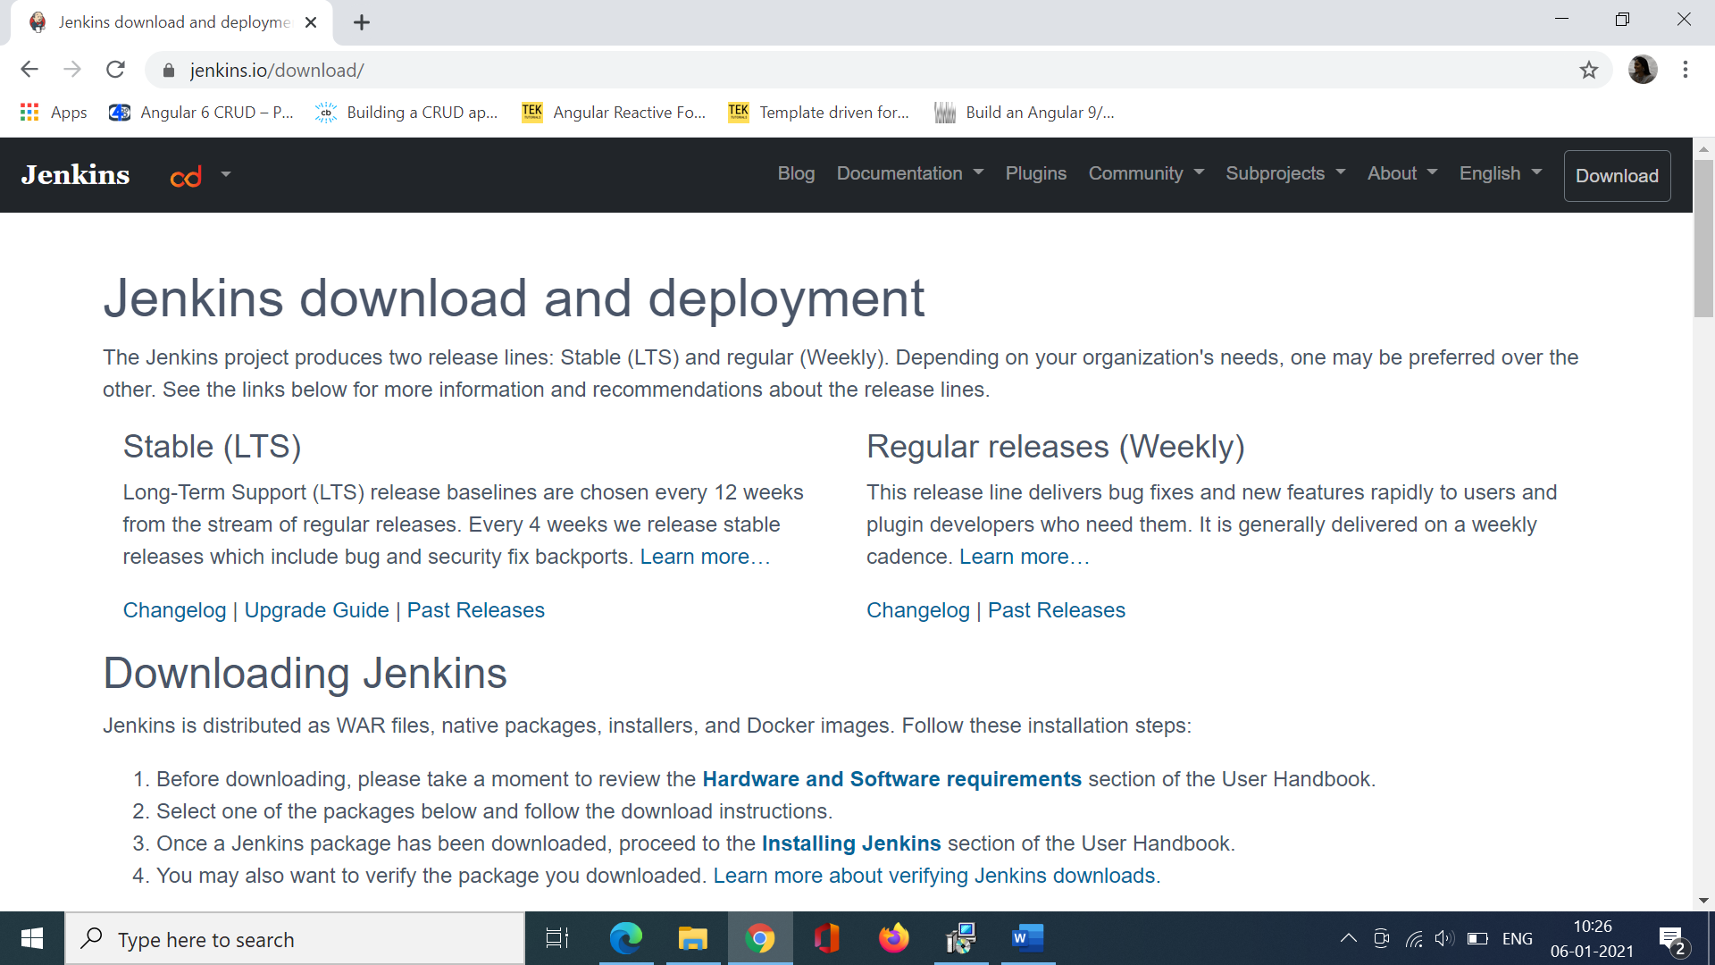

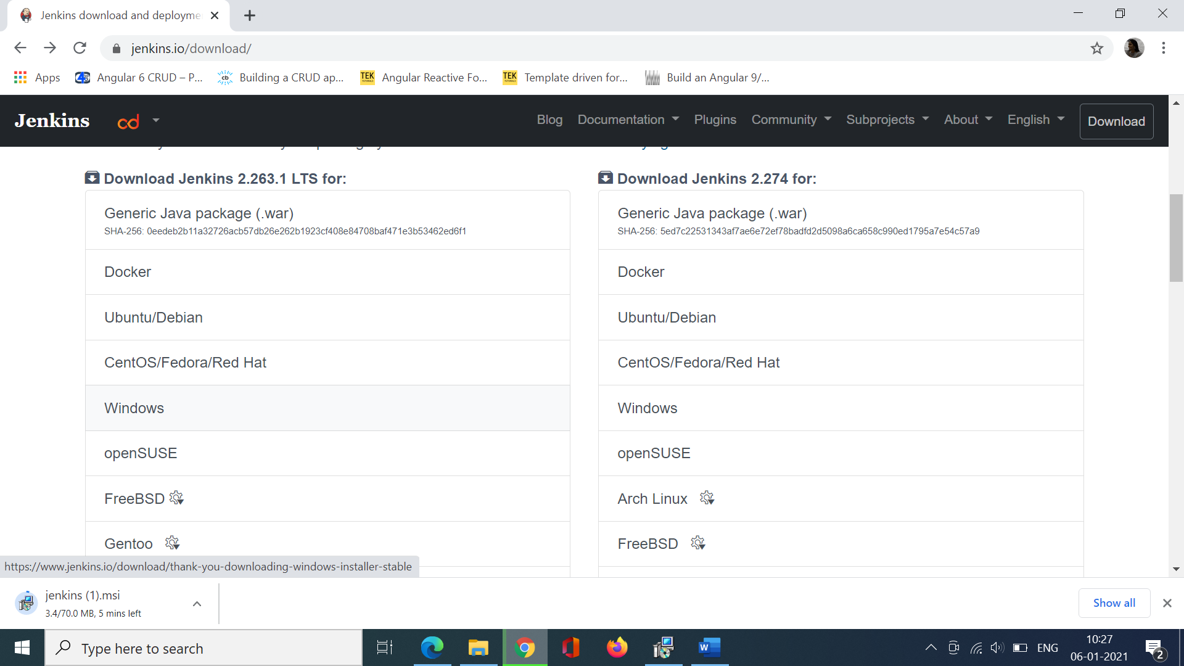

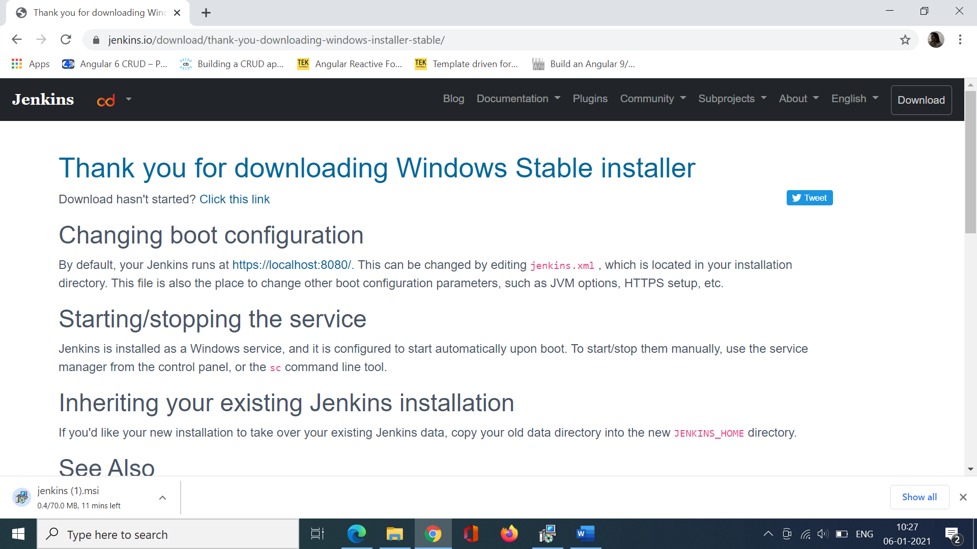

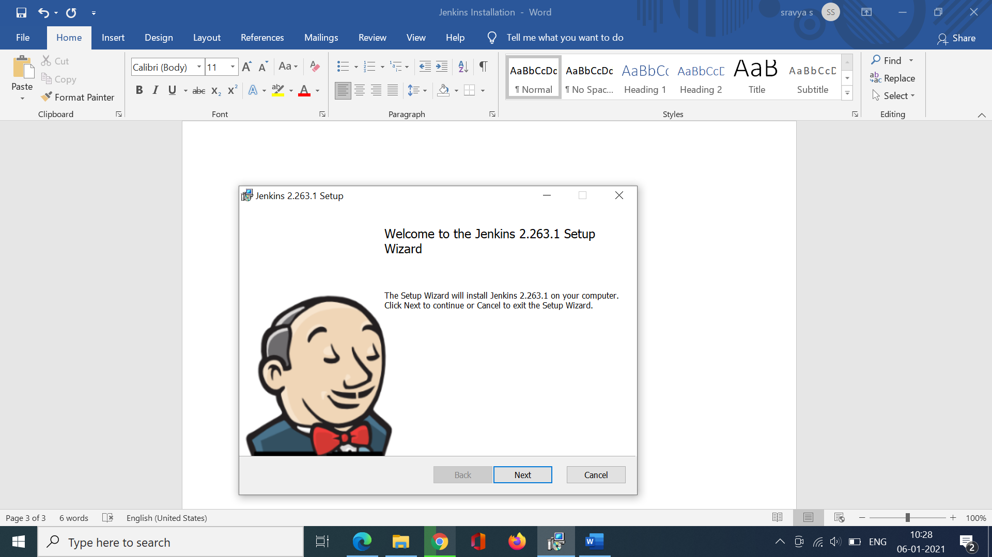

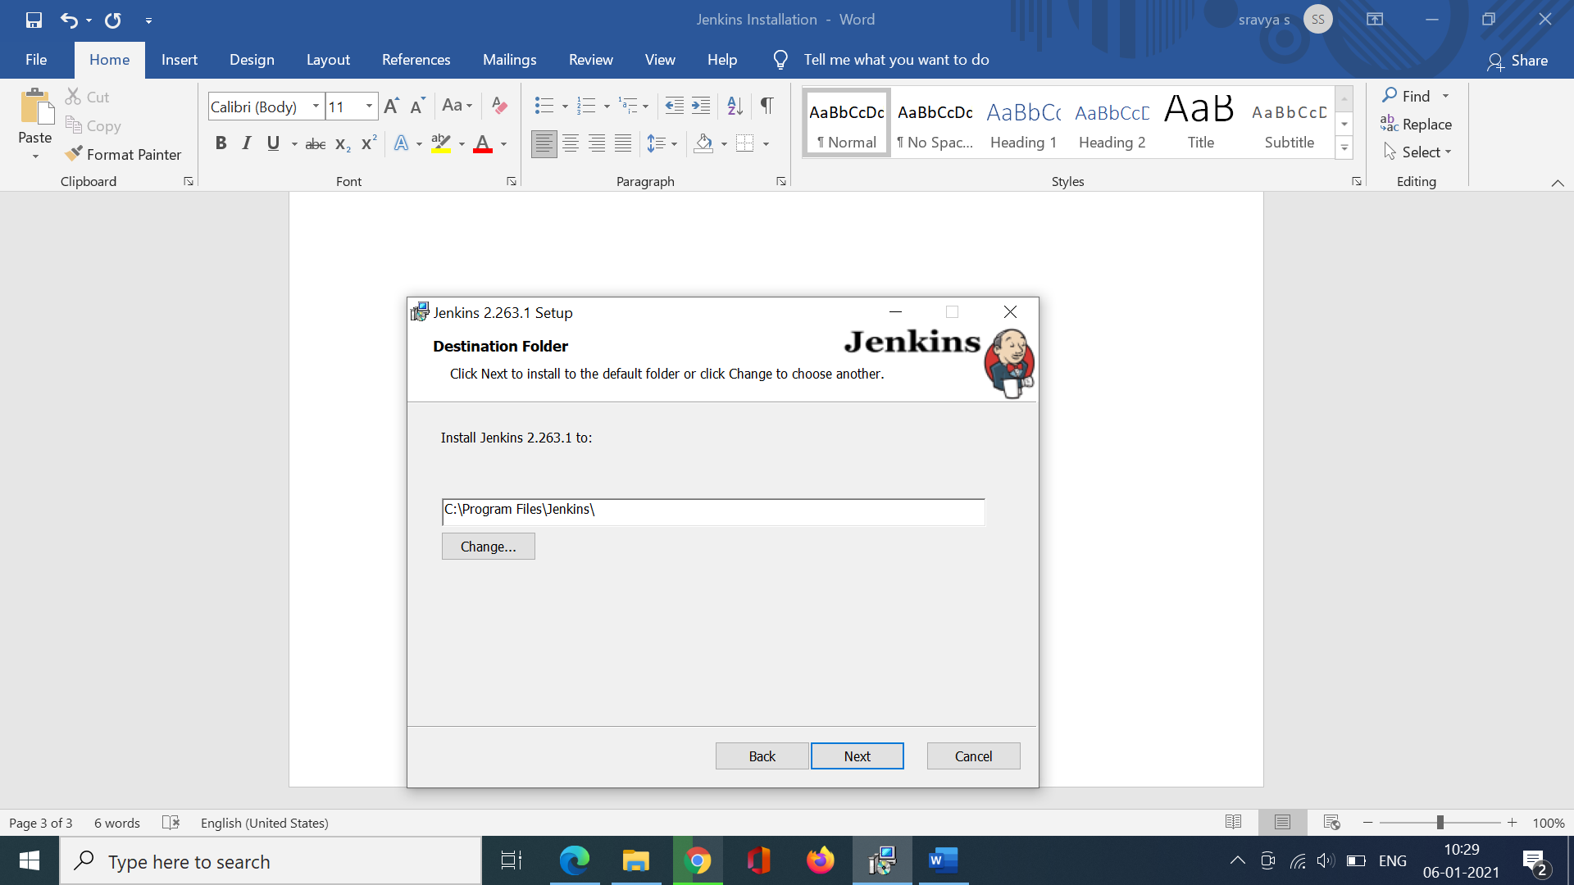

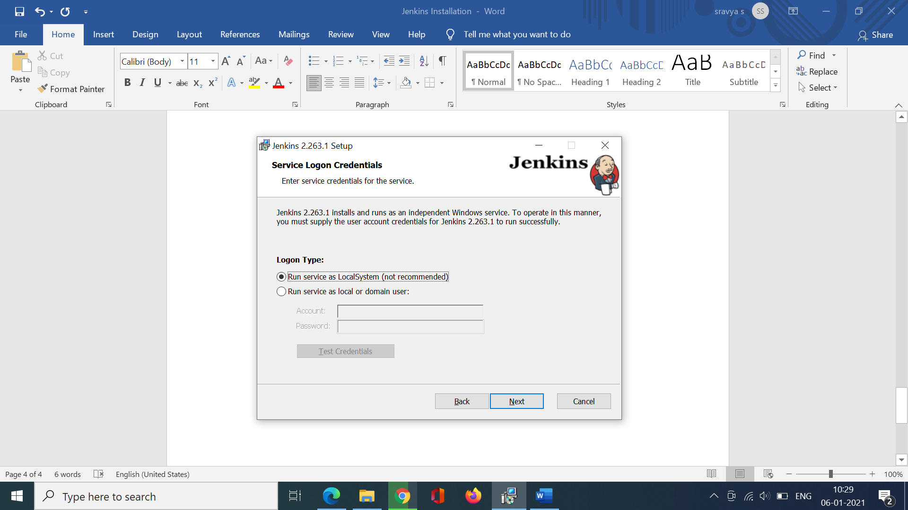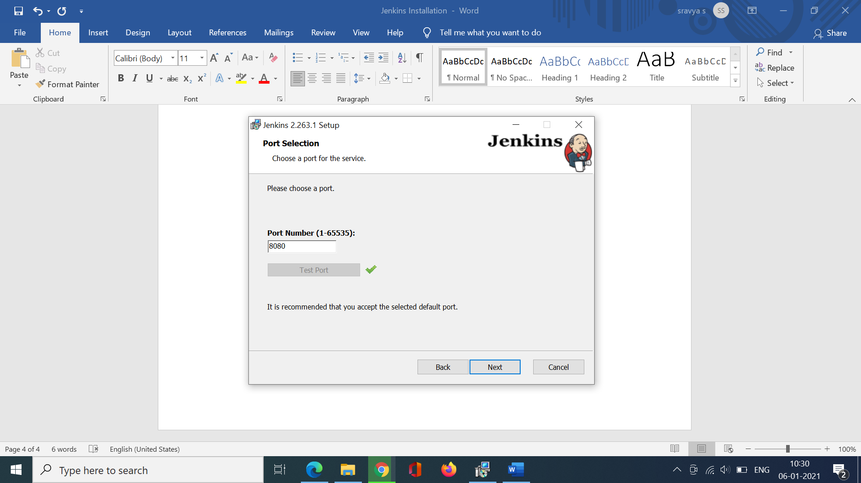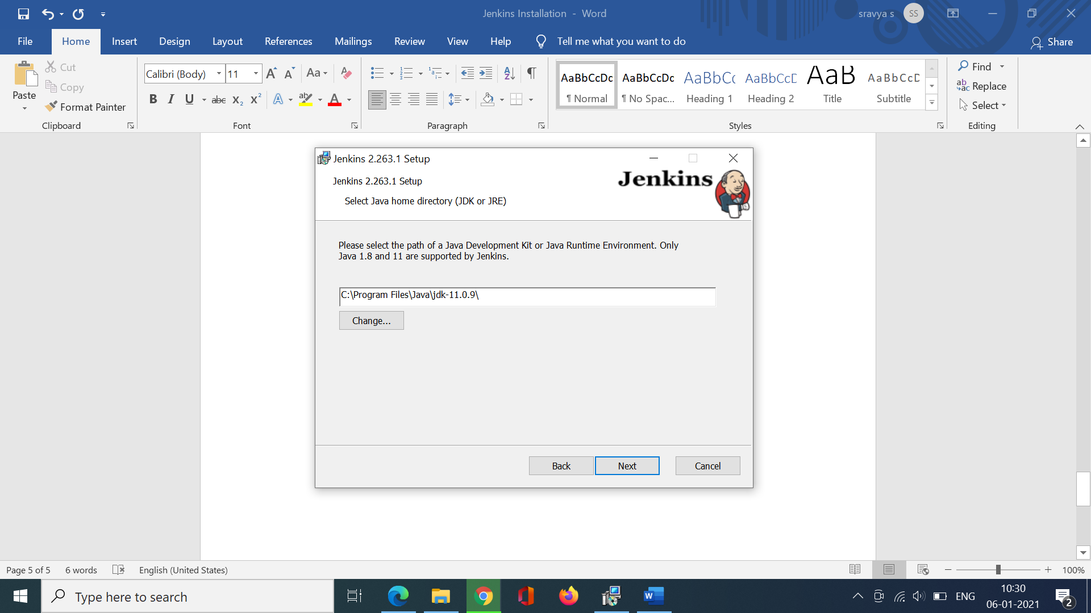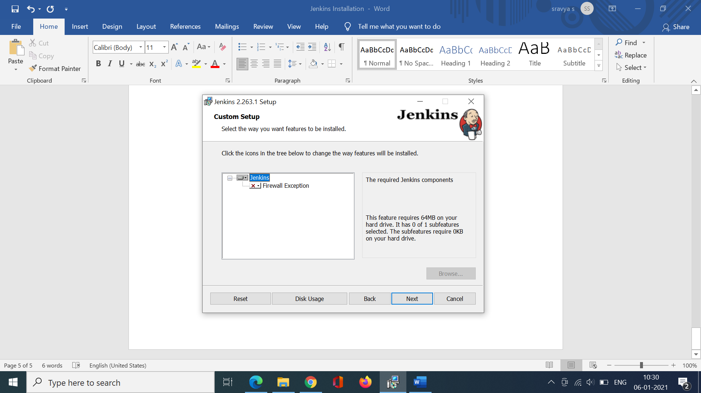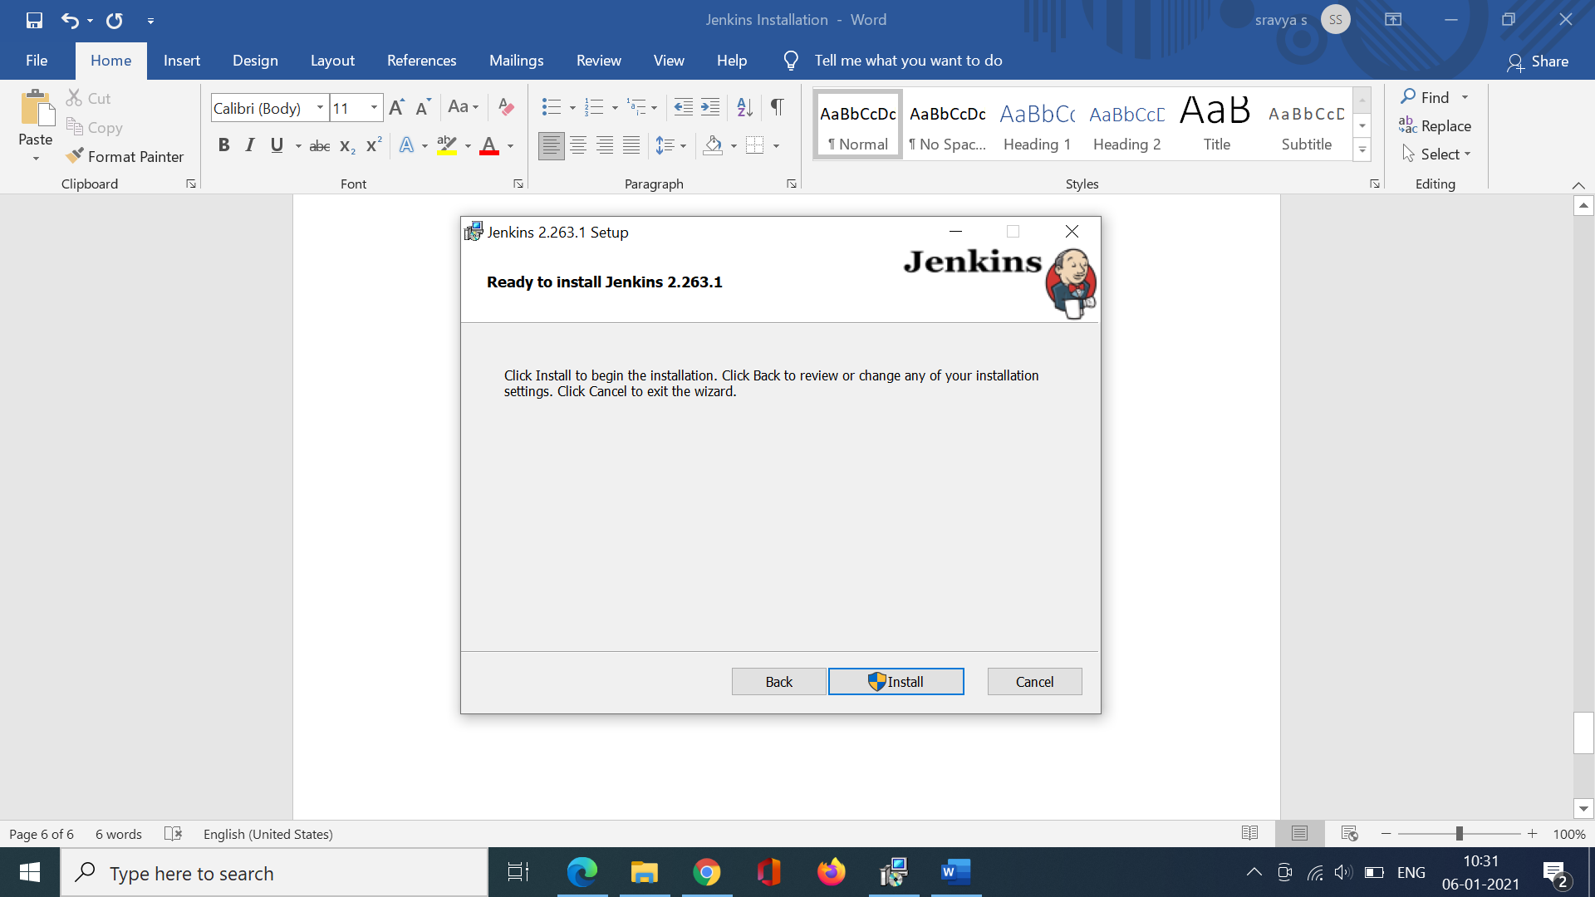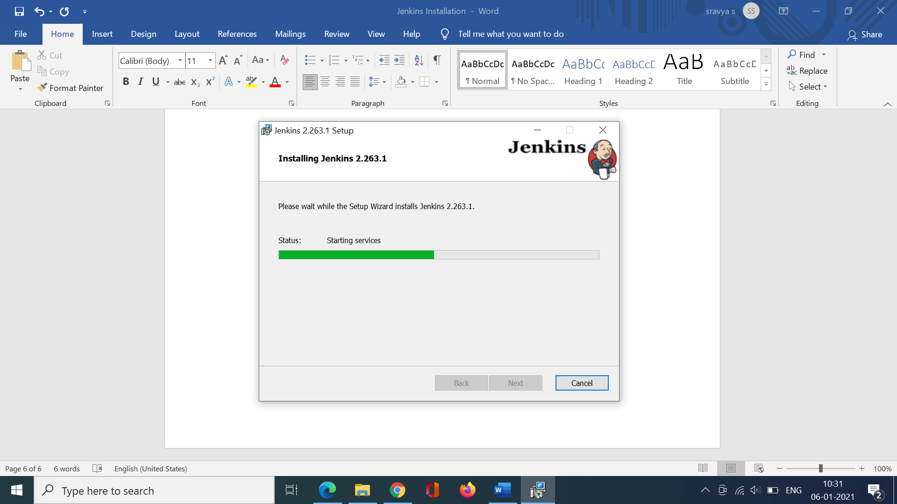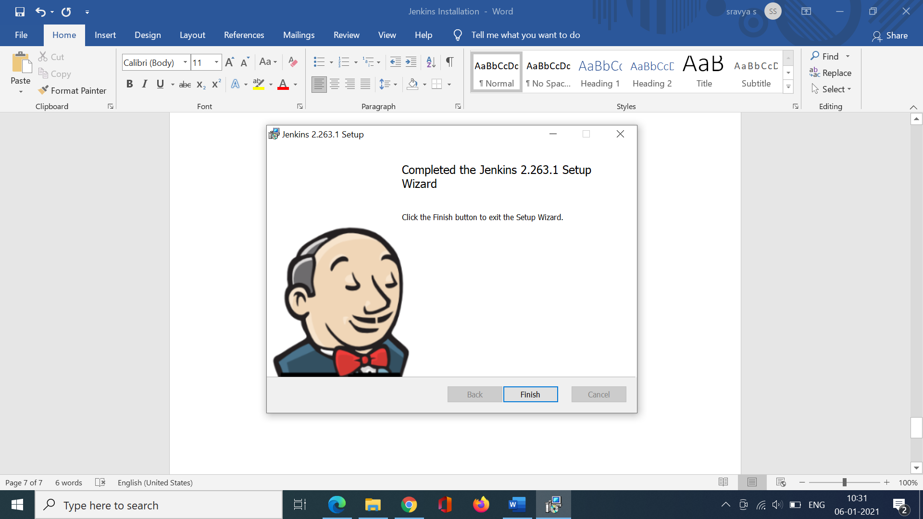

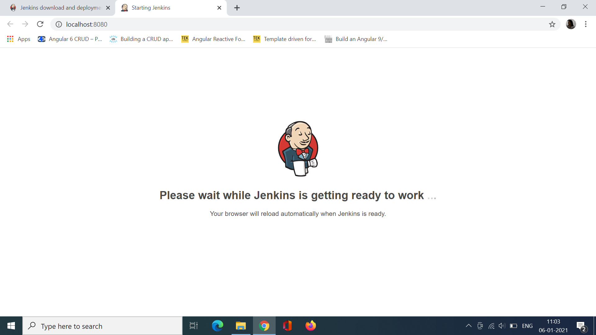

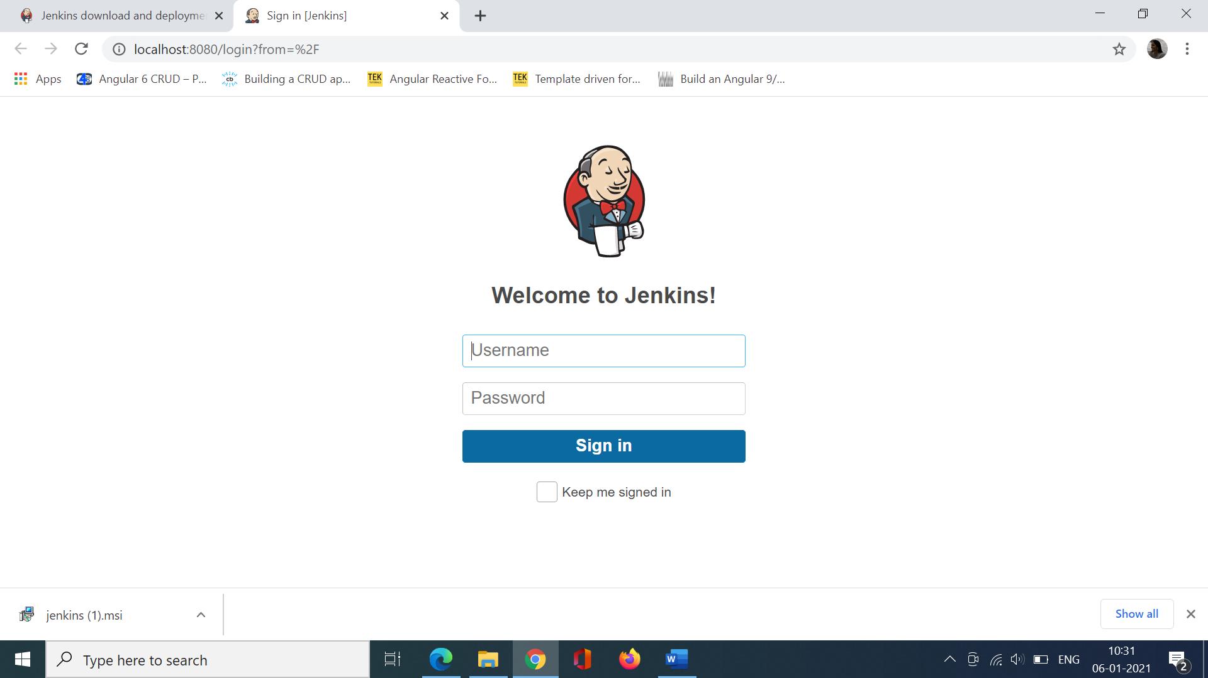

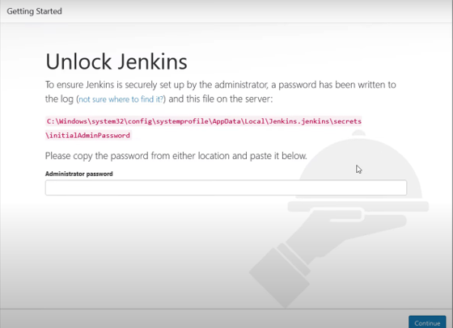

In case the username and password is lost goto C:\Windows\System32\config\systemprofile\AppData\Local\Jenkins\.jenkins

Open Config.xml

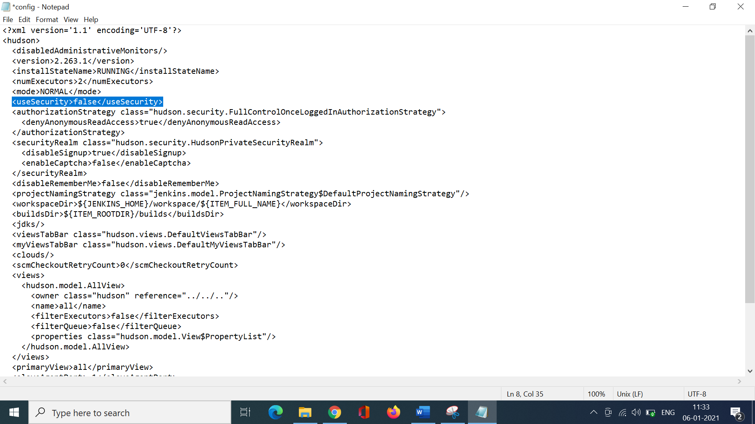

Change the user security to false.

Now goto command prompt from the jenkins location

*jenkins.exe stop*

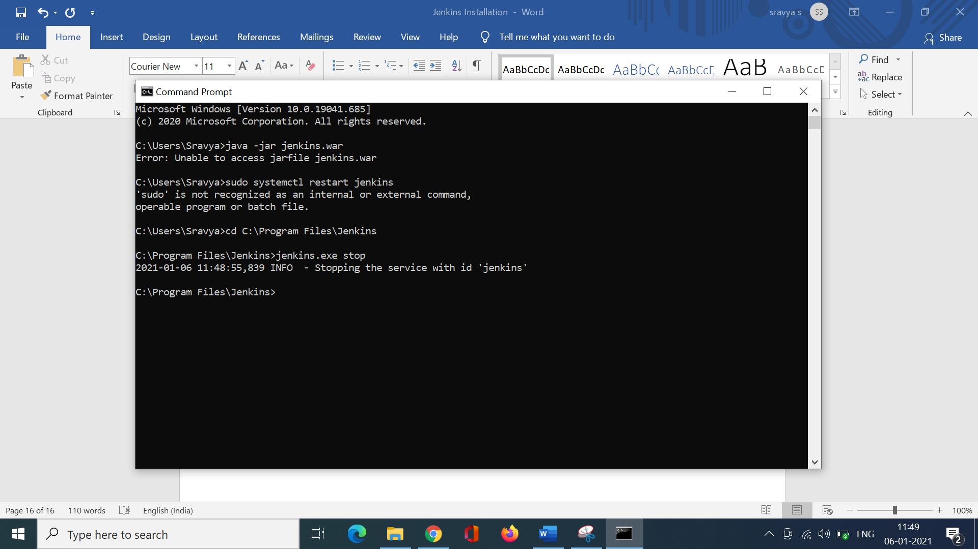

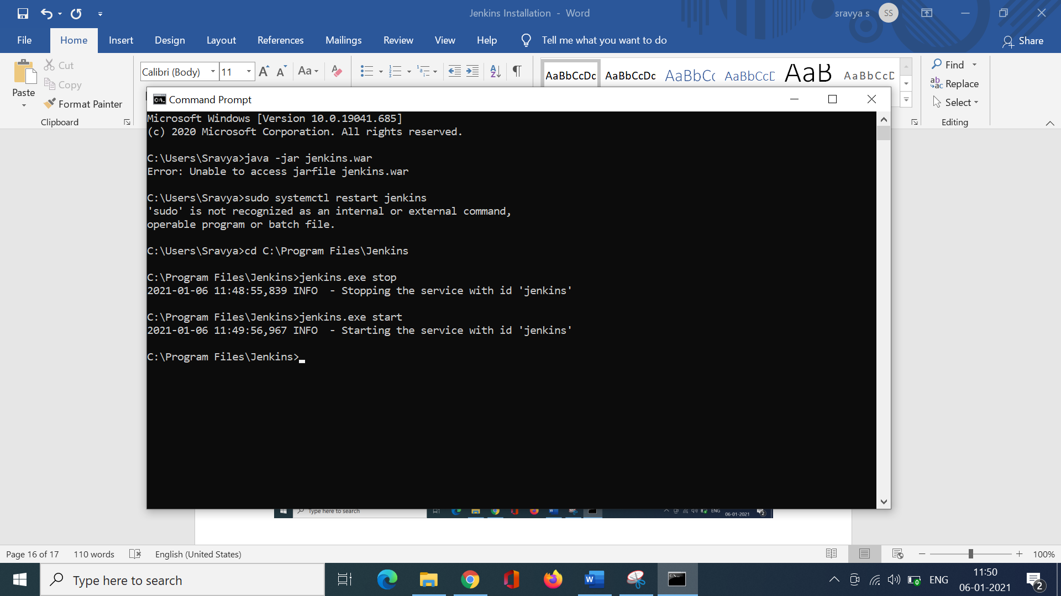

Now Jenkins will load without authentication. You can view the dashboard. To reset credentials.

Click on Mange Jenkins->security->configure global security

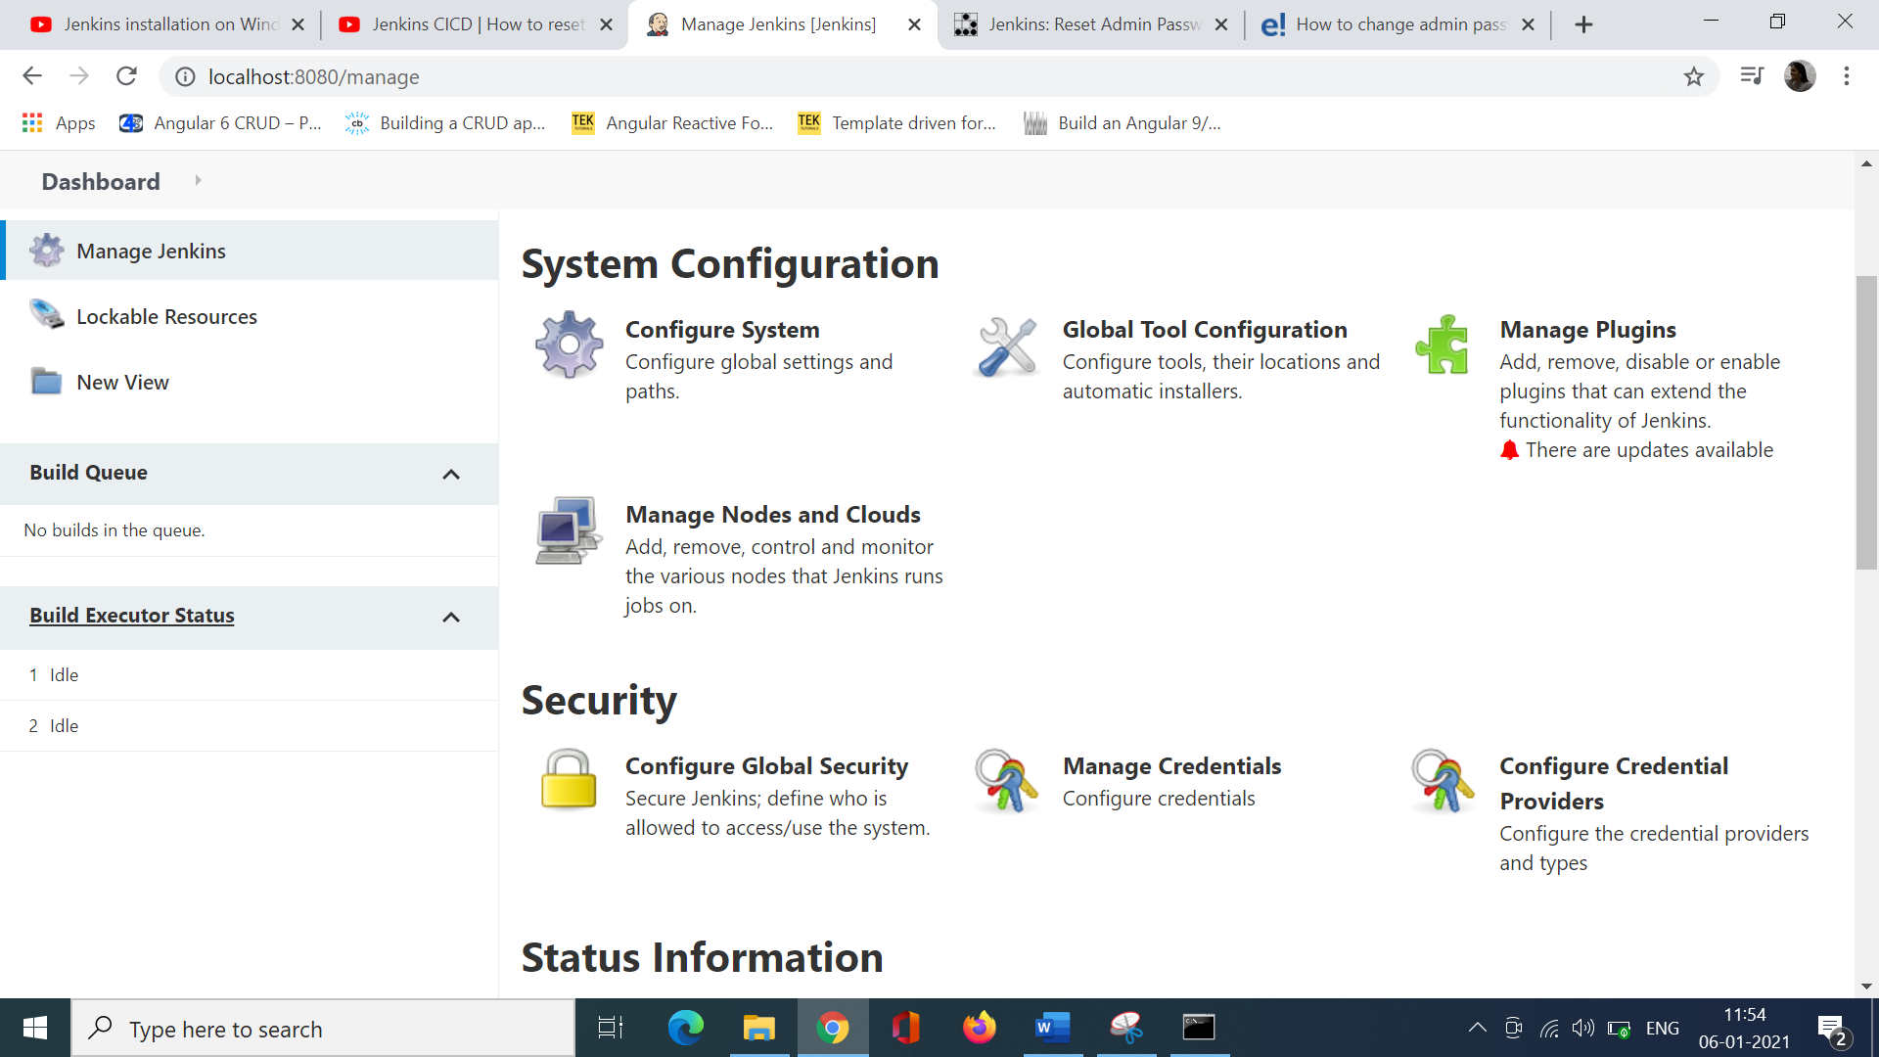

Reset Jenkins Admin’s Password

After Jenkins restarts navigate to the web console. Notice that you were not prompted for a username or password. This is because we disabled security in Jenkins’ configuration file.

If this is a publicly shared Jenkins instance, you should disable public access to the server until the password reset is complete.

To reset admin’s password, do the following.

1. Click on**People** on the left-hand navigation menu.
2. Click on the **Admin**.
3. Delete the user account.
4. Navigate to**Jenkins / Manage Jenkins**.
5. Click on **Configure Global Security**
6. Check the **Enable Security** check box
7. Under **Security Realm**, select **Jenkins’ own user database**
8. In the **Authorization** section, select **Logged-in users can do anything.**
9. Unselect **Allow anonymous read access**.
10. Click **Save** to save your changes.

Create New Jenkins Admin User

Once you have completed the tasks above, you will be redirect to a page where a new Admin user can be created. Fill in your new details and then click **Create First Admin User**.

You have now created a new Admin user with a new password.

Username:admin

Pwd:admin@2020

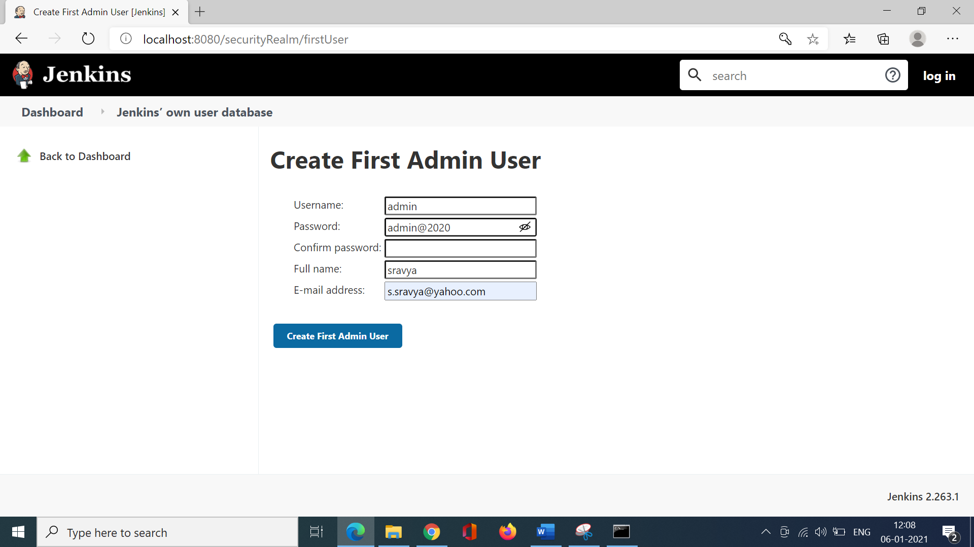

Push the project to the Git.

Now goto Jenkins Dashboard.

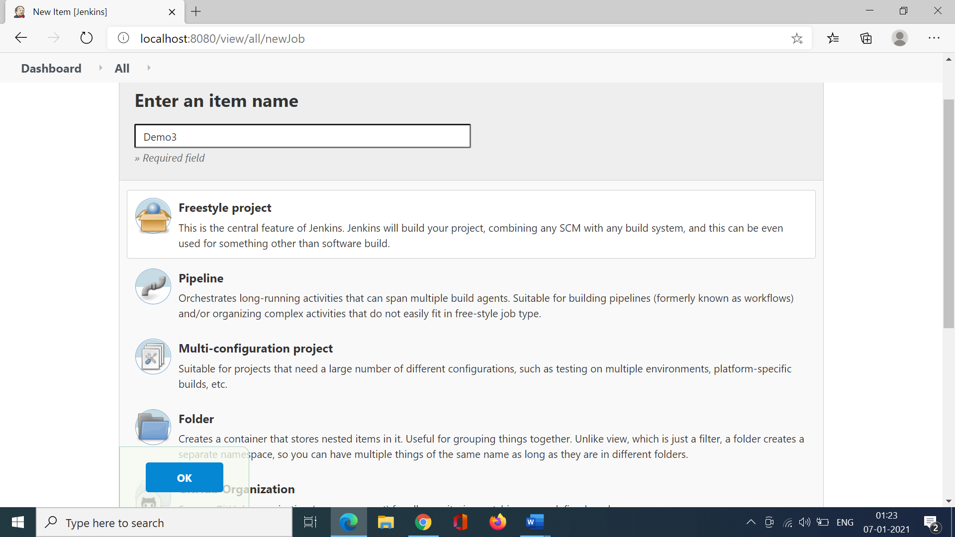

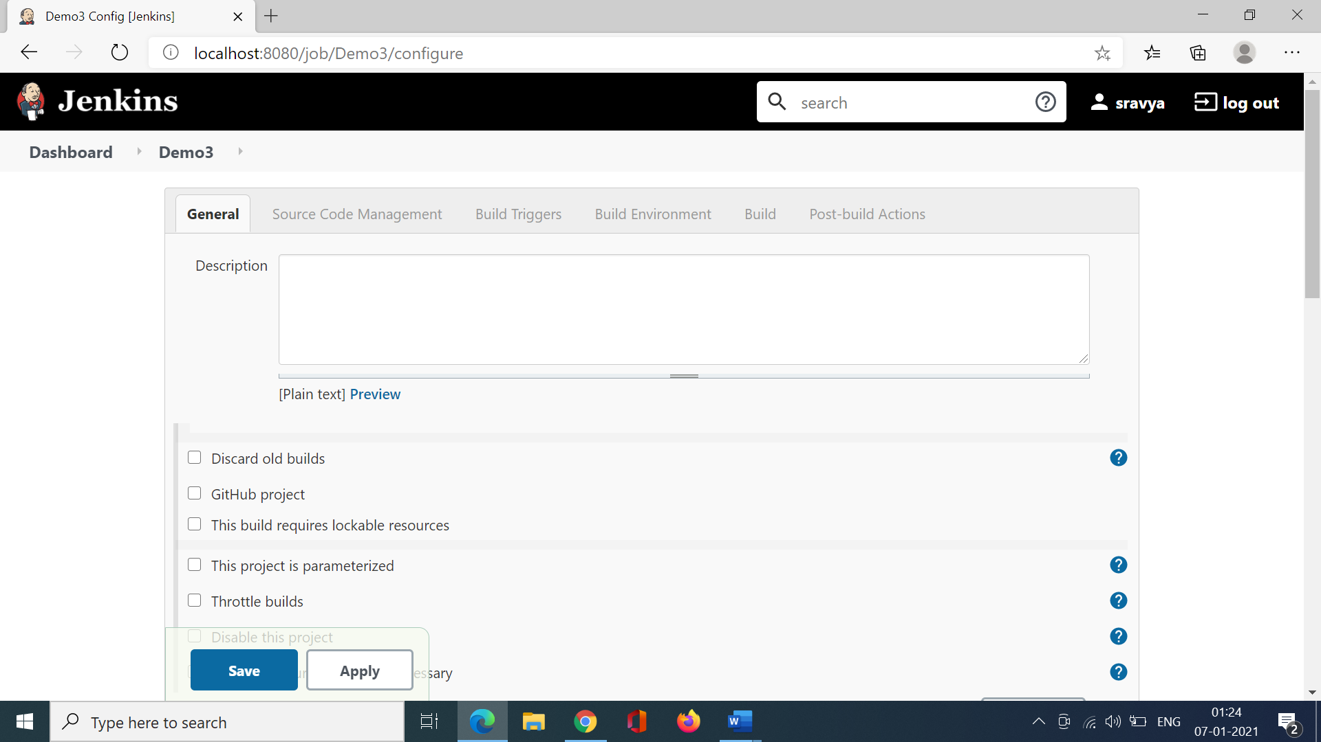

Goto Github and copy the repository link.

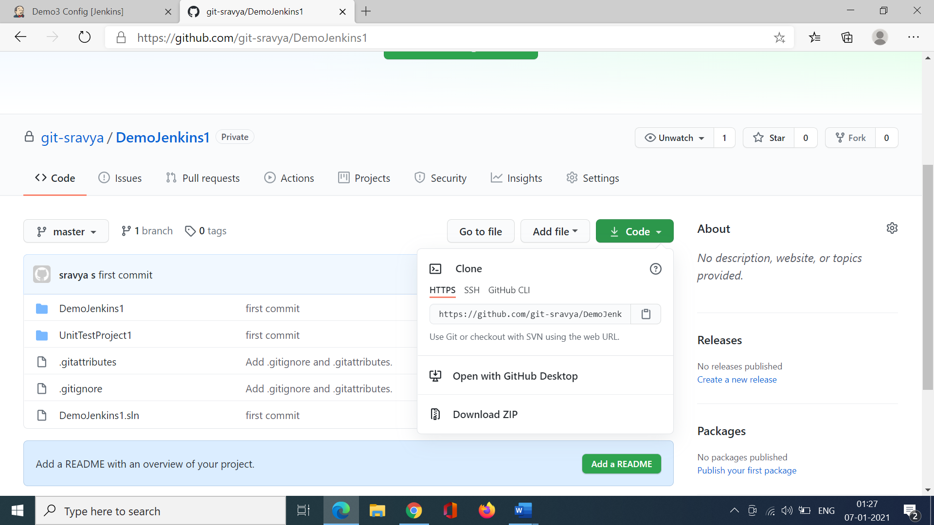

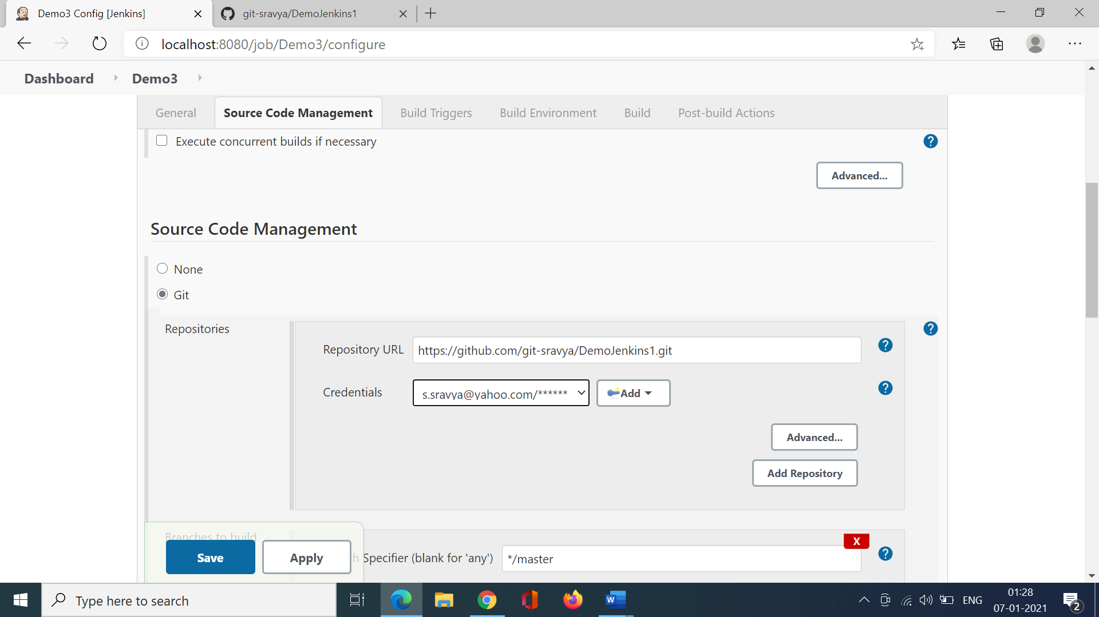

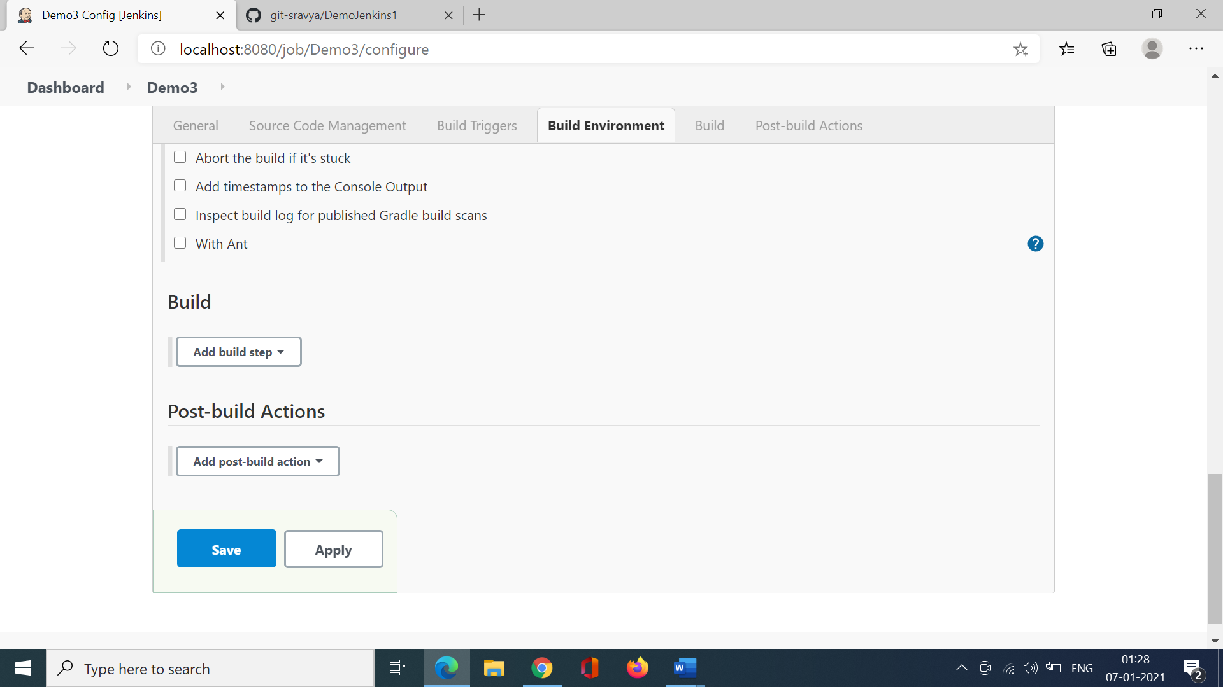

Once you save the project is saved in Jenkins.

Choose Build now on the left to build it.

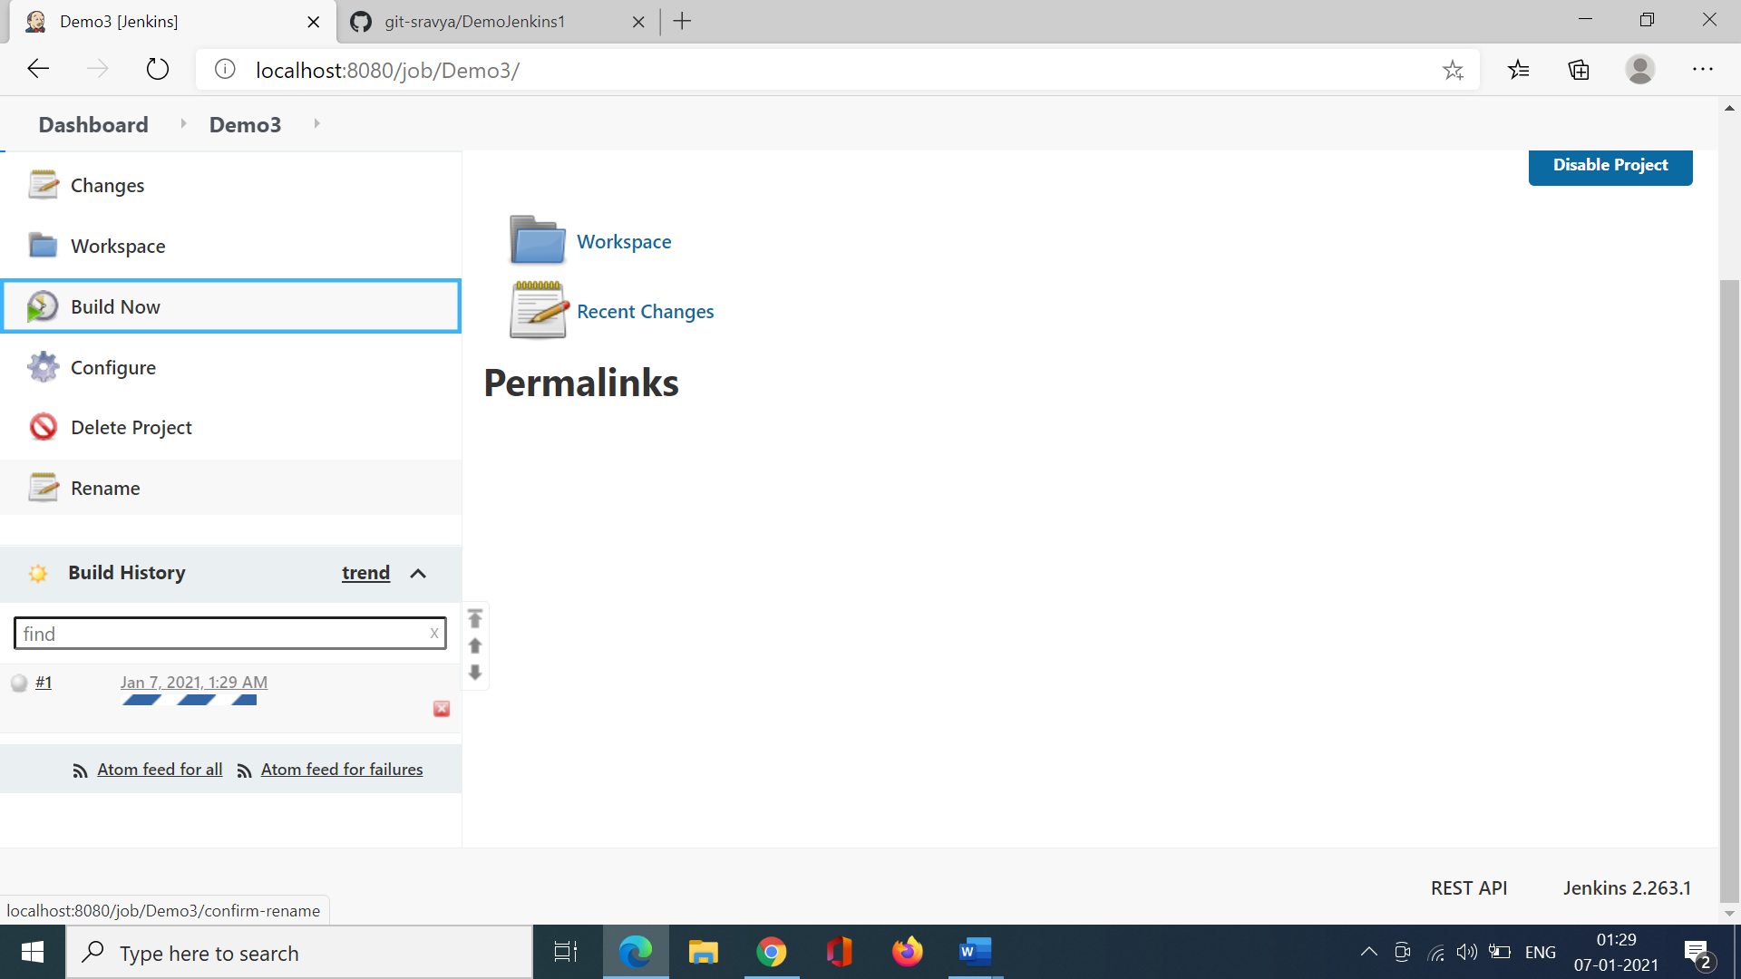

Click on build history to check the build status.

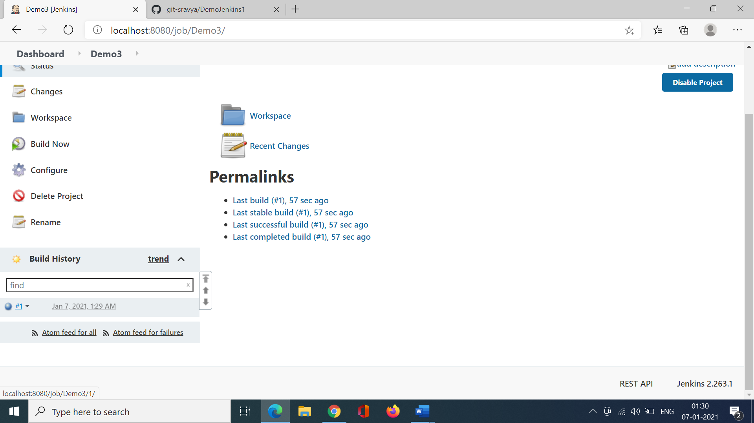

Click on it. Goto Console output .

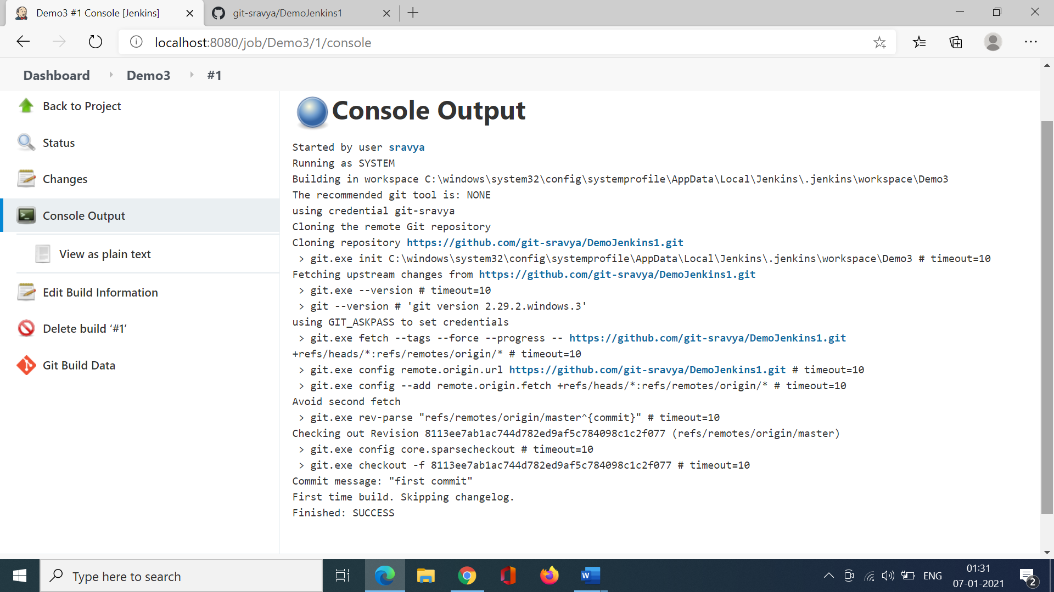

Configure the MSBuild in Jenkins to build it. Goto Manage Jenkins.

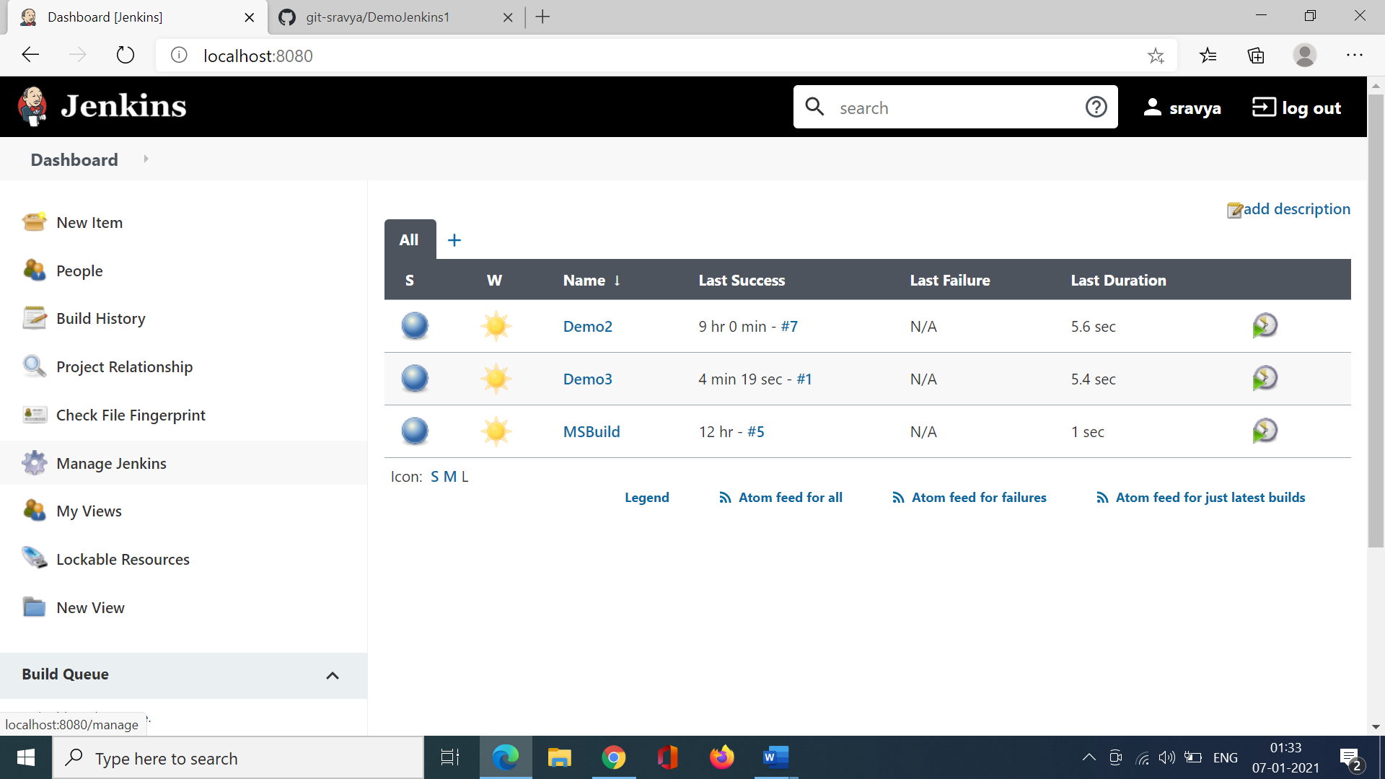

Goto Manage Plugins

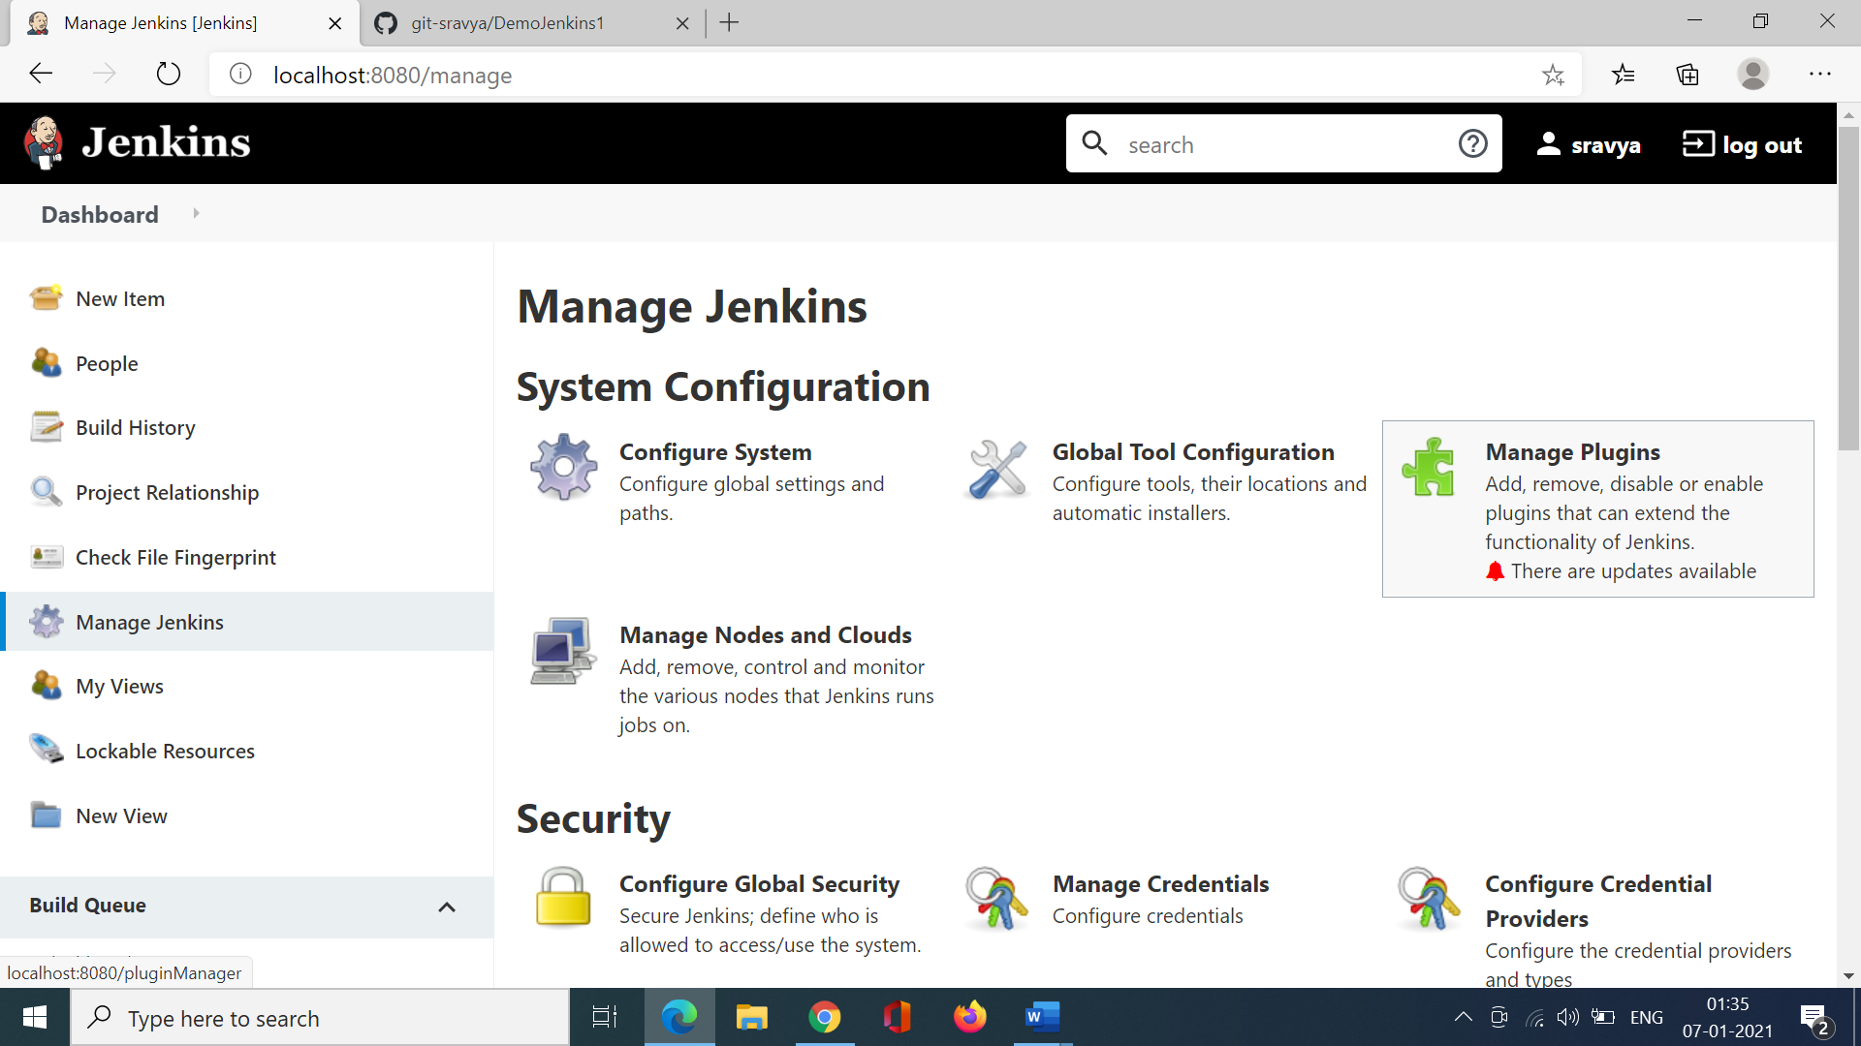

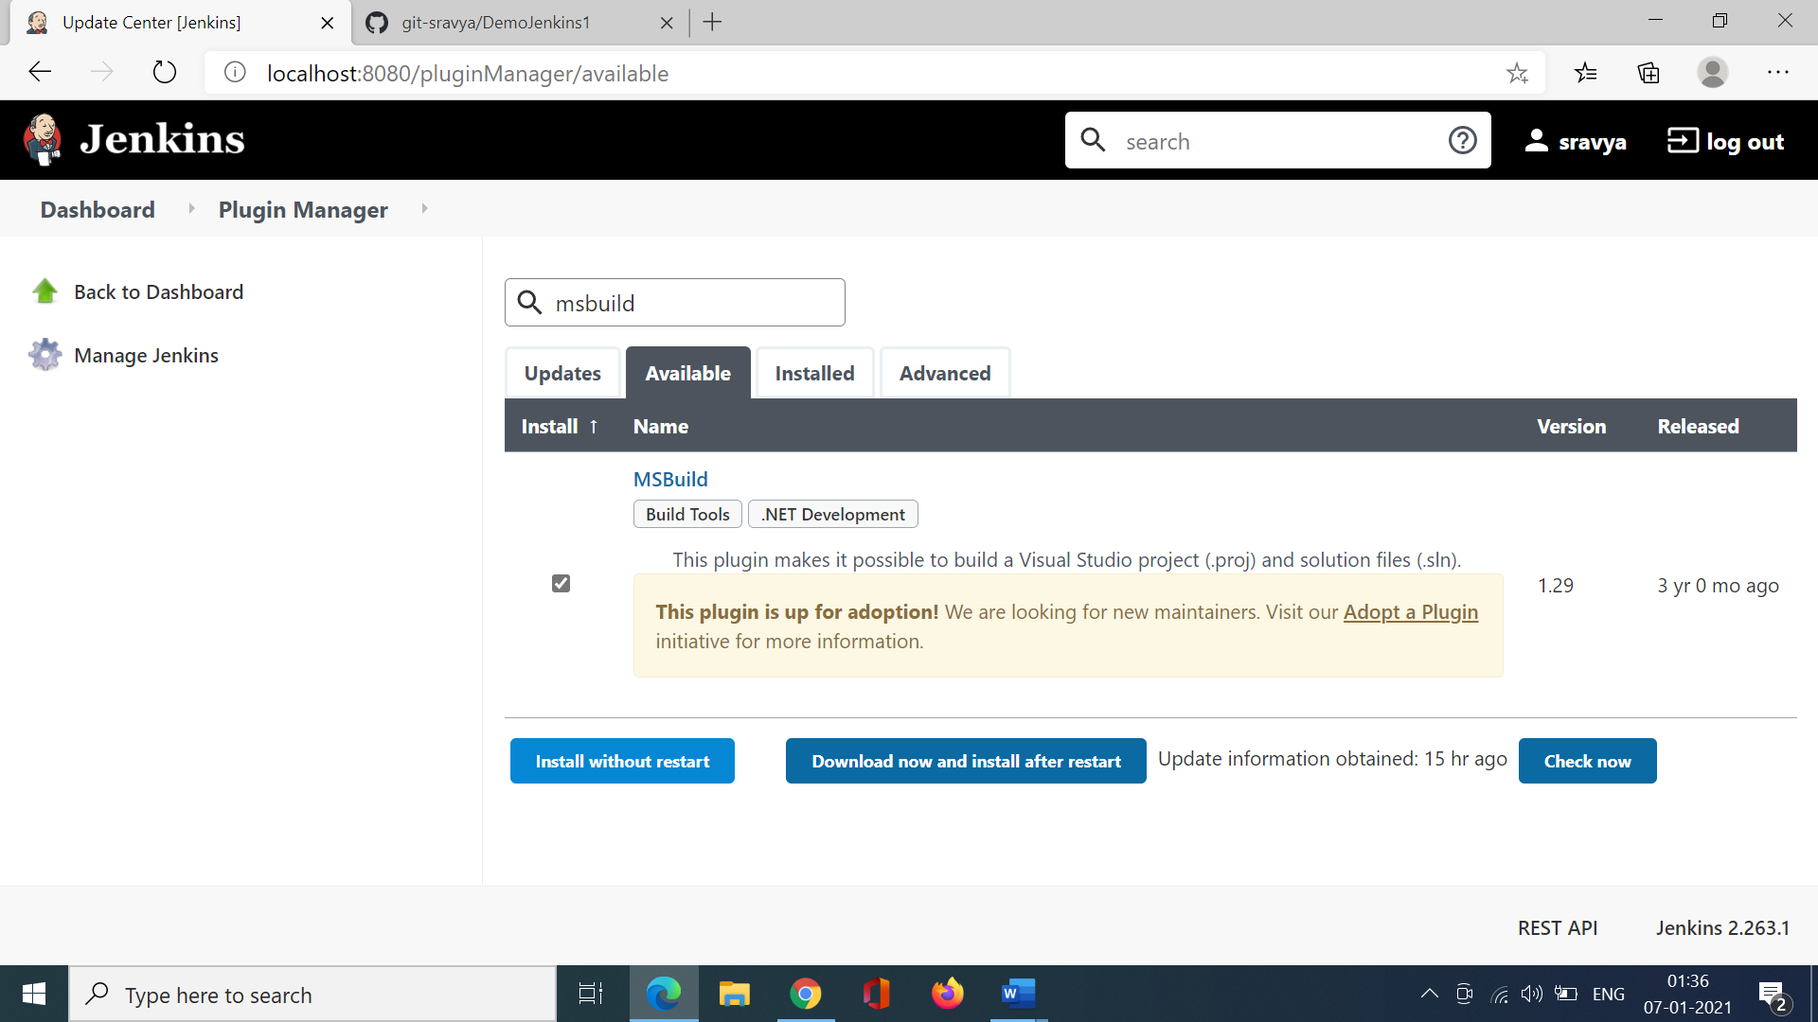

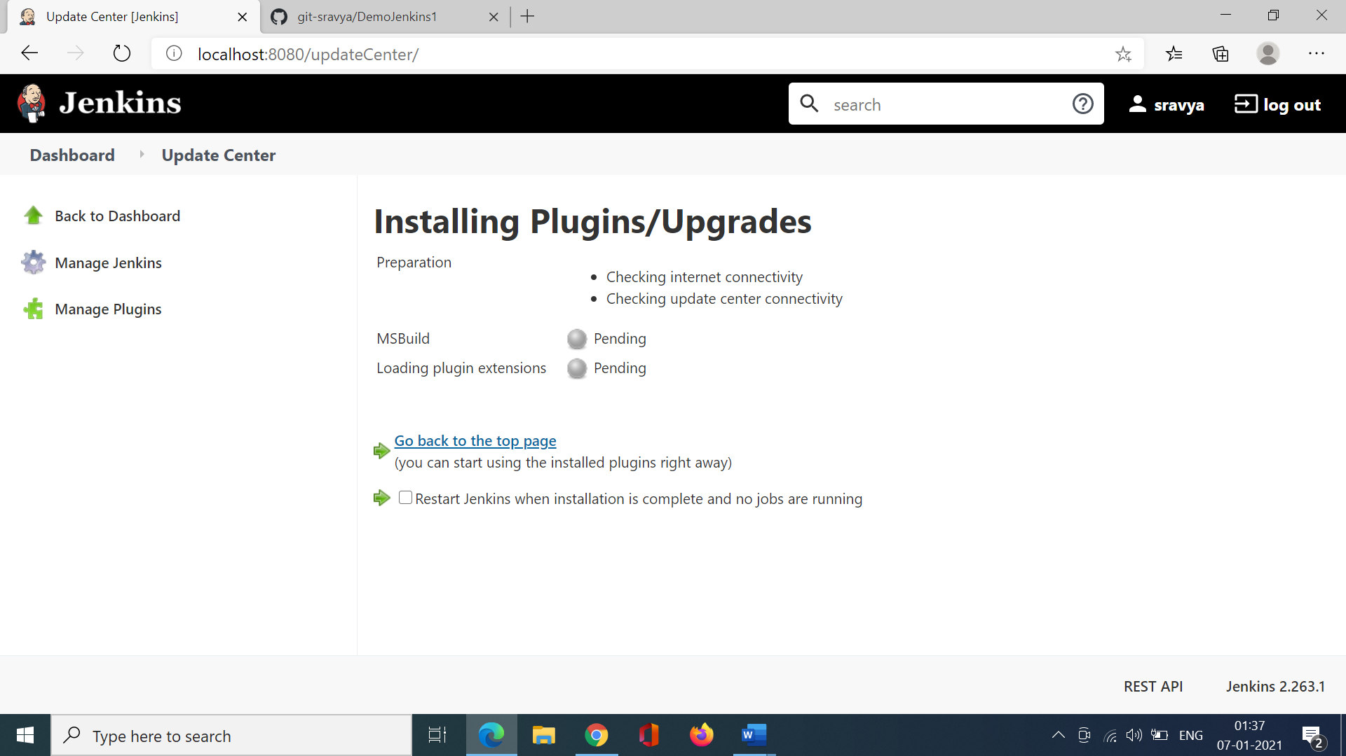

Once the MSBuild plugin is installed successfully goto the project.

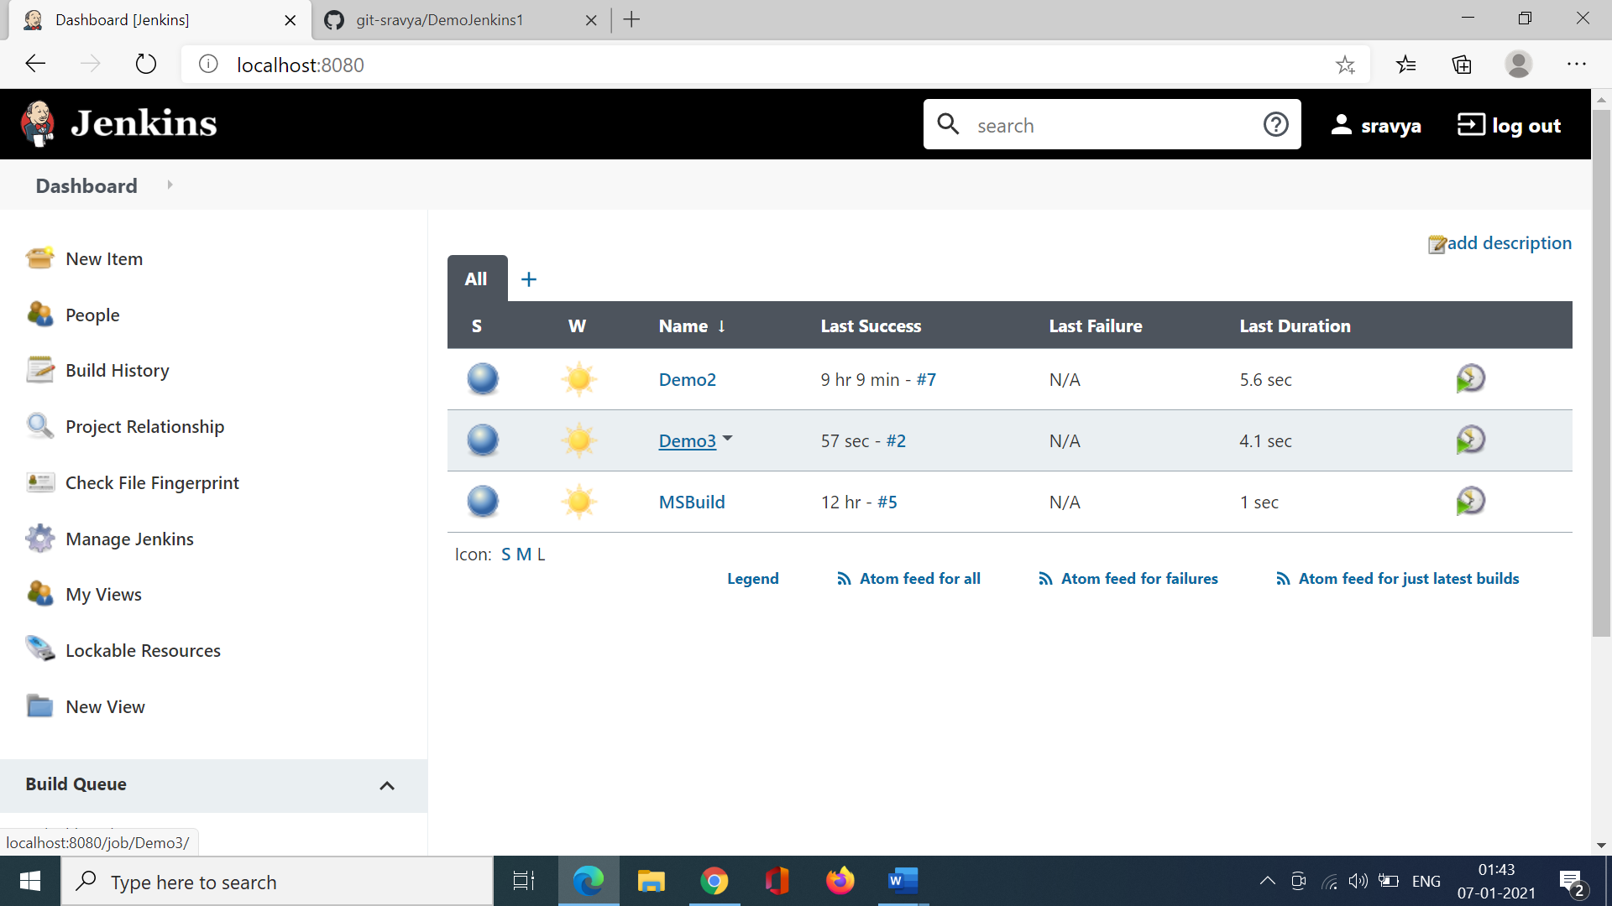

Goto Configure

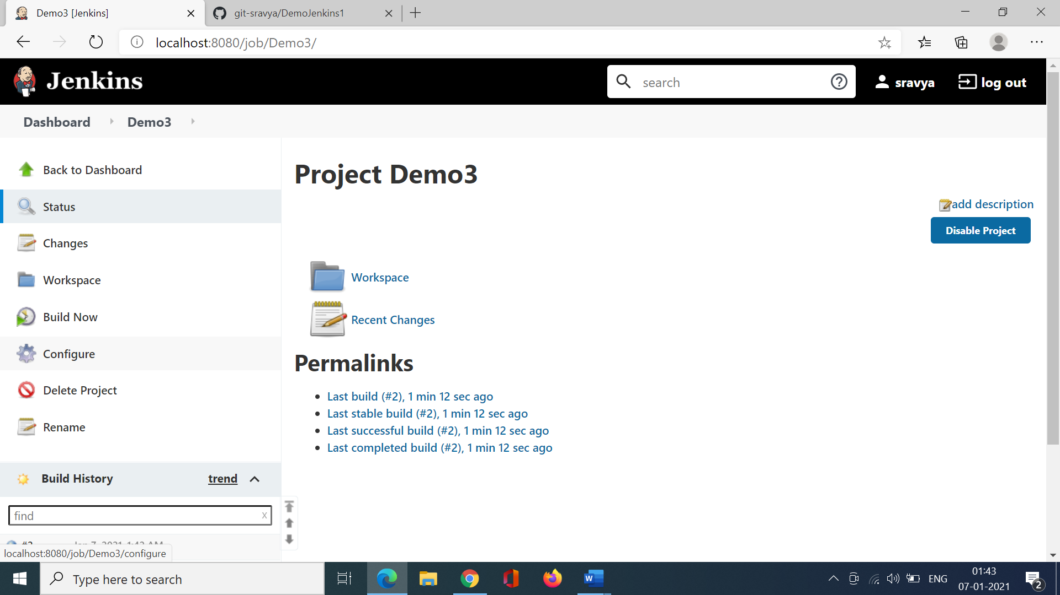

Choose visual studio project

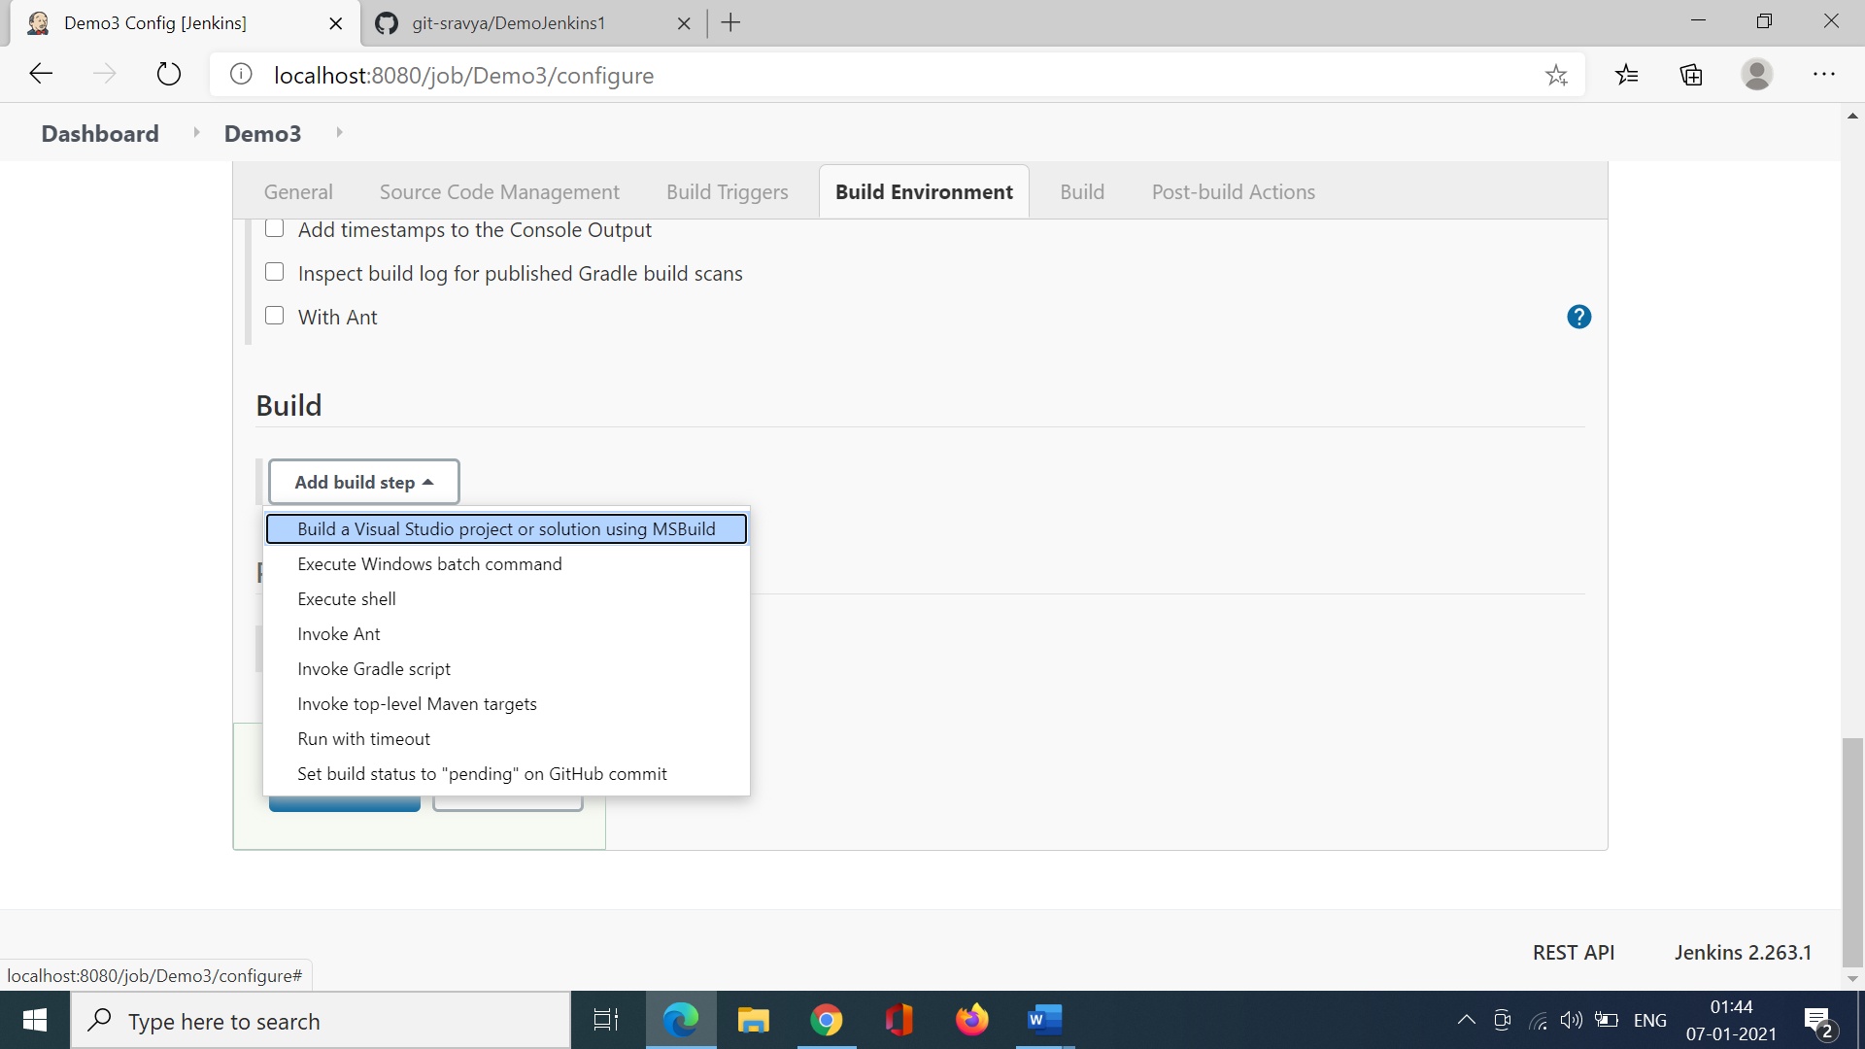

C:\Users\Sravya\source\repos\Jkdm\jkdm.sln

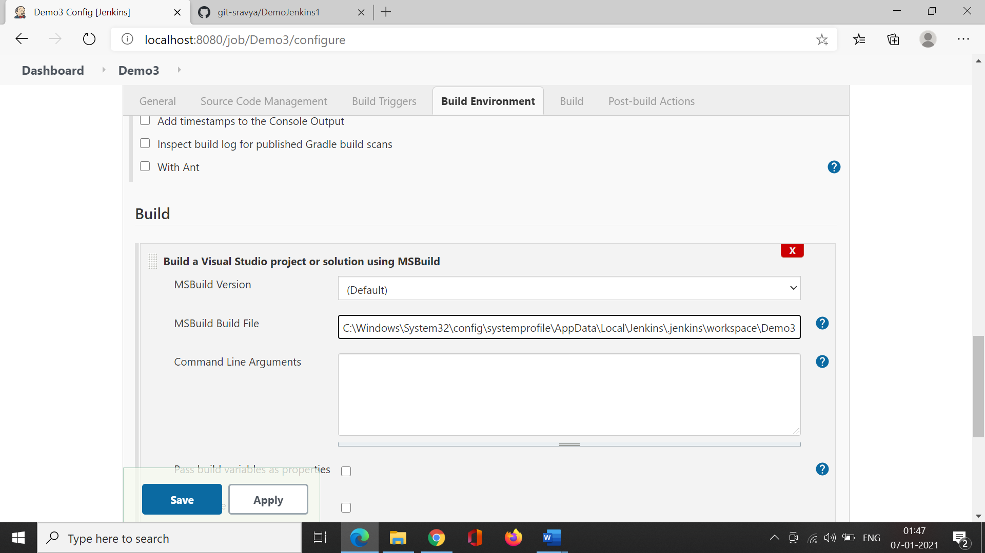

Click save.

Goto Mange Jenkins -> Global Tool Configuration

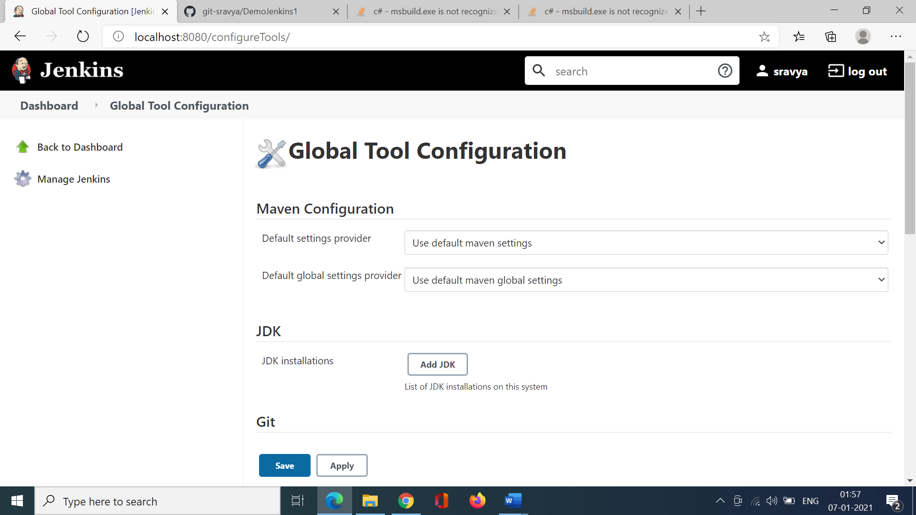

Choose Add MSBuild

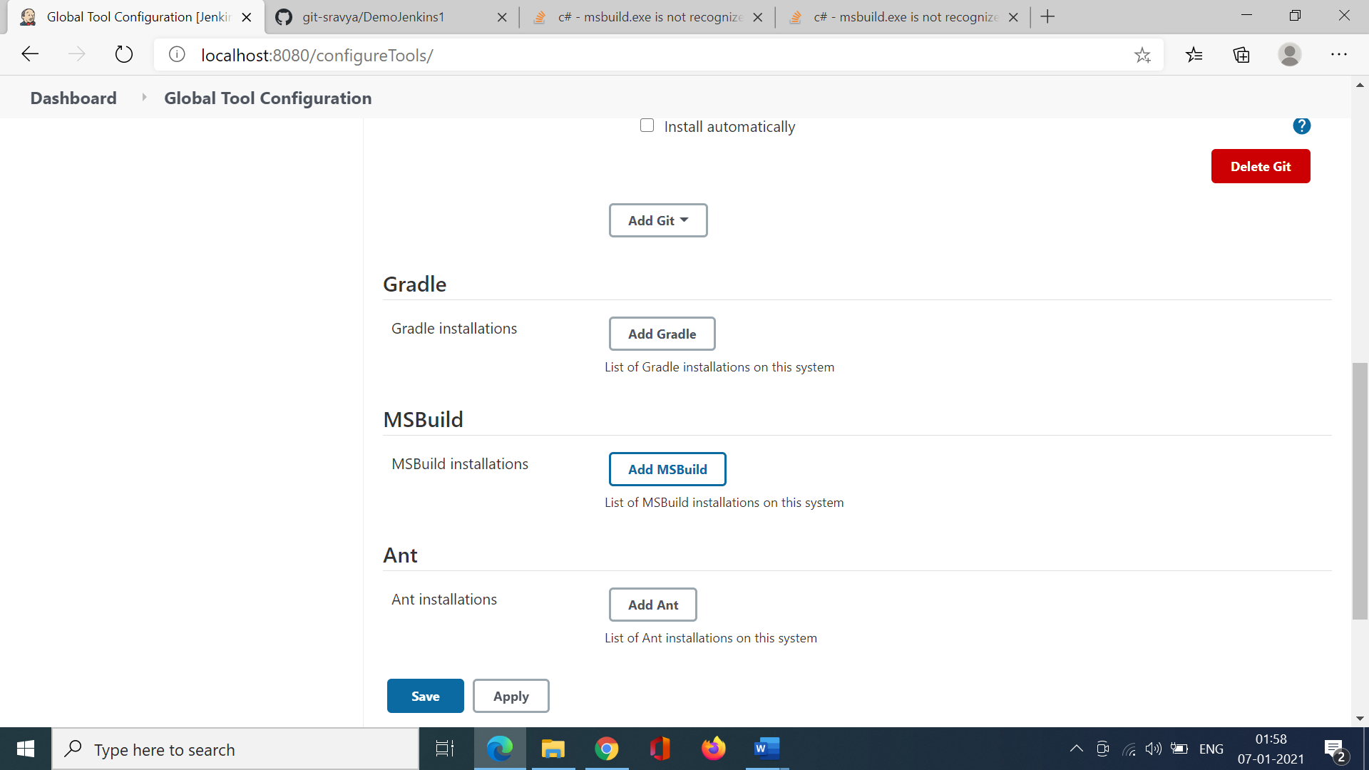

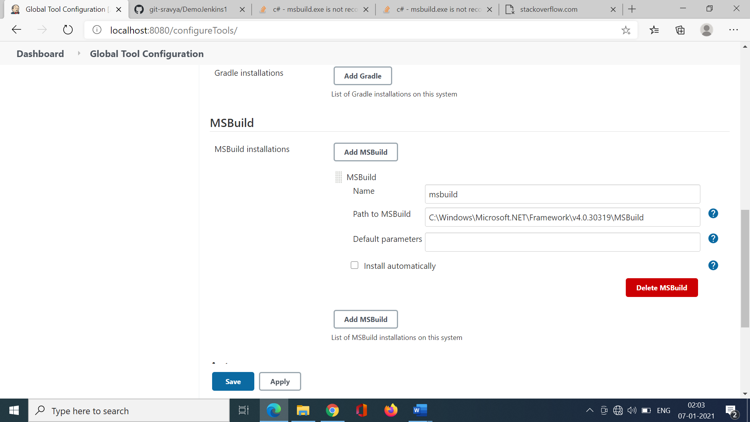

Save.